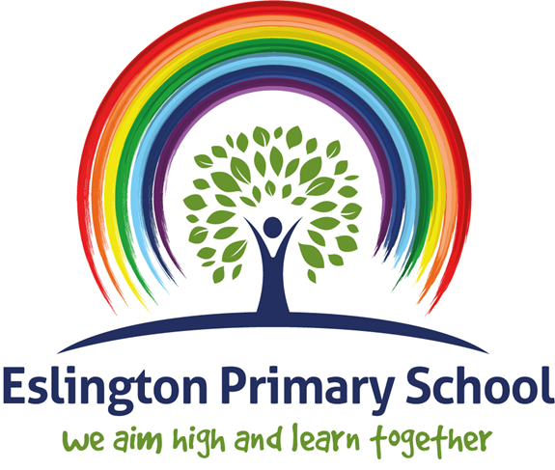

Art Policy

2023-24

National Curriculum Definition of Art
Art, craft and design embody some of the highest forms of human creativity. A high-quality art and design education should engage, inspire and challenge pupils, equipping them with the knowledge and skills to experiment, invent and create their own works of art, craft and design. As pupils progress, they should be able to think critically and develop a more rigorous understanding of art and design. They should also know how art and design both reflect and shape our history, and contribute to the culture, creativity and wealth of our nation.
National Curriculum 2014

Rational
At Eslington we believe “Every child is an Artist”, all children are naturally creative, it is our job as educators to inspire them. Art provides children with a sense of freedom where there are no limits. Being able to express themselves creatively empowers them and builds their confidence, enabling them to communicate their thoughts, ideas and observations in a practical and expressive way. Through evaluation and collaboration children develop their social and emotional skills when reflecting on their works and that of others. Creativity is unique to each individual. At Eslington we encourage children to learn and develop in a multi-sensory way through various experiences, materials, tools and techniques, children can record the world around them in a creative way.

Aims

The school should ensure that all children:
- Produce creative work, exploring their ideas and recording their experiences.
- Become proficient in drawing, painting, sculpture and other art, craft and design techniques.
- Evaluate and analyze creative works using the language of art, craft and design.
- Know about great artists, craft makers and designers, and understand the historical and cultural development of their art forms.
- Have entitlement to a broad and balanced, enriching curriculum.
- Enjoy an active involvement in art, craft and design.
- Have the confidence and experience necessary to communicate their ideas through their artwork.
- Have the opportunities to experience a broad and balanced range of art activities and show progression within these experiences.
- Have opportunities to learn about art from different times and cultures.
- Become visually literate and able to identify and apply the key elements of art.
- All pupils will be given equal access to the experience of the art regardless of the gender, race or disability.

Teaching Objectives

National Curriculum subject content:

Key Stage 1
Pupils should be taught:

- To use a range of materials creatively to design and make products.
- To use drawing, painting and sculpture to develop and share their ideas, experience and imagination.
- To develop a wide range of art and design techniques in using colour, pattern, texture, line, shape, form and space.
- About the range of artists, craft makers and designers, describing the differences and similarities between different practices and disciplines and making links to their own work.

Key Stage 2
Pupils should be taught to develop their techniques, including their control and use of materials with creativity, experimentation and an increased awareness of different kinds of art, craft and design.

Pupils should be taught:
- To create sketch books to record their observations and use them to review and revisit ideas
- To improve their mastery of art and design techniques, including drawing, painting and sculpture with a range of materials (for example, pencil, charcoal, paint, clay)
- About great artists, architects and designers in history.

Creative Curriculum
A Long Term Plan is included with this policy along with the Key Skills to be completed across both Key Stages 1 and 2.

Teaching and Learning Strategies
Art is an activity that needs the teacher to be directly involved with the children in the lesson to set the task, to impart knowledge, to lead activities, to monitor and develop the children's progress, to encourage development and to ensure that each child reaches an appropriate standard.

- Use a variety of approaches matched to the activity and the children's ability.
- Children must be given the opportunity to examine exhibits, artifacts, and historical buildings of interest.
- Clearly identify whether the art activities are exclusively art or whether they are applying skills through one or more aspects of the wider curriculum, as in topic work. When children are undertaking activities that are directly related to another element of the curriculum they should be aware that the session is an art investigation and that they are therefore focusing upon art skills.
- Develop clear links between Art and Computing to prove opportunity to develop the children's capabilities.
- Ensure always that issues of Health and Safety are addressed in the planning and delivery of the art curriculum.
- Children must be encouraged to work individually, in pairs, small groups and as a whole class when required.

Planning

Matching tasks to pupil’s abilities:

Teaching in art should address the fact that all children will develop their ability to make images and to learn and apply skills at different rates. Differentiation is therefore a key issue and will be open ended and planned differentiation will be by the outcome and by tasks set according to ability. Individual children will be supported by relevant questions from the teacher. These interventions from the teacher to individuals will increase their thinking, extend the range of options that may be considered and raise individual standards. There will also be times when the individual needs are met through differentiated tasks. Both approaches need to be used to ensure that all children can be working to their full potential in all art lessons.

Skills in the Foundation Stage are planned through the objectives within the EYFS Development Matters Document.

Teachers from Foundation Stage to Year 6 will plan to ensure full coverage of the skills relating to the Art and Design curriculum for that year group throughout the year. Teachers will plan before the start of each new theme, and at this point highlight the skills that will be covered.

Cross Curricular Learning

Cross curricular teaching through the use of Art is to be encouraged. It is recommended Teachers deliver Art through Topic lessons (where possible); this will allow children to produce creative aspects of work relating to their current Topic. E.g. Natural Disasters/ Victorians this way of teaching art enables teachers to become creative and provides endless opportunities to each child. This will be shown through ‘Rainbow Challenges’ which will be located in children’s Topic books under the blue heading. The use of appropriate teaching and learning strategies should enable pupils learning and encourage creative thinking and imaginative ways of working.

Record Keeping, Assessment and Reporting

As in all other areas of the curriculum, assessment is an integral part of the teaching process. The class teachers should keep records of work carried out these will be located in the class Teachers Assessment file. Photographs are a useful tool to keep as a reminder of pupils’ achievements. Photographs and Videos will also be uploaded to each individual classes ‘Seesaw’ account.

Formative assessment is used to guide the process of individual pupils in Art and Design. It involves identifying each child’s progress in each aspect of the curriculum, determining what each child has learnt and what should therefore be the next step in their learning. Formative assessment is mostly carried out informally by the teachers in the course of their teaching and should be based on the identified assessment opportunities. Teachers work closely with each other to moderate children’s artwork and children’s knowledge skills and understanding are then tracked using the school Art Tracker.

Children’s progress in Art and Design is reported to parents through the pupil annual report and termly consultation meetings throughout the year.

Use of Sketchbooks

Sketchbooks are used from EYFS through to year 6 to regularly record, collect and explore ideas and images and other information relevant to current and ongoing work. The sketchbook is an essential and personal record although teachers will teach children when it is appropriate to use them and for what purposes including reviewing the contents to ensure the purpose of the sketchbook at frequent intervals.

The contents of the sketchbook could include:

Experiments with using various marking media drawings in a range of media that are:

- A record of what has been seen
- Preparatory studies for further work
- The development of ideas for further study
- Photograph and other illustrative material to support ongoing work
- Colour schemes and trials
- A record of observations seen outside the classroom which will be used a reference material for further work, for example on a school visit
- Details of something that will be drawn or painted in entirety
- ICT prints and image manipulations

Sketchbooks are an essential record of an individual child's experiences and ideas throughout a year and key stage and will be seen as evidence for assessment and reporting purposes.

Health and Safety

Children should be working in a safe environment both in and outside of the classroom. The relevant risk assessments must be completed when using any potentially dangerous equipment, such as scissors or craft knifes. When conducting fieldwork, children should be properly supervised and should be made aware of any potential dangers, such as busy roads or water hazards.

Monitoring

The monitoring of coverage and progress across the school will be done by the subject co-ordinator in consultation with teachers.

Role of the Co-Ordinator:

- Produce the Art Policy and the Key Stage plans that meet the statutory requirements.
- Produce the Art progress of skills which highlights a breakdown of skills for each year group.
- Produce the Art key vocabulary detailing the differences in vocabulary to be used throughout each year group and in conjunction with the progress of skills document.
- Provide advice to teachers or seek information to help support with appropriate resources and approaches to assessment.
- Co-Ordinator to purchase and organize the appropriate art resources.
- Attend relevant in-service courses and give feedback to staff new information and ideas.
- Monitor Teaching and Learning.

