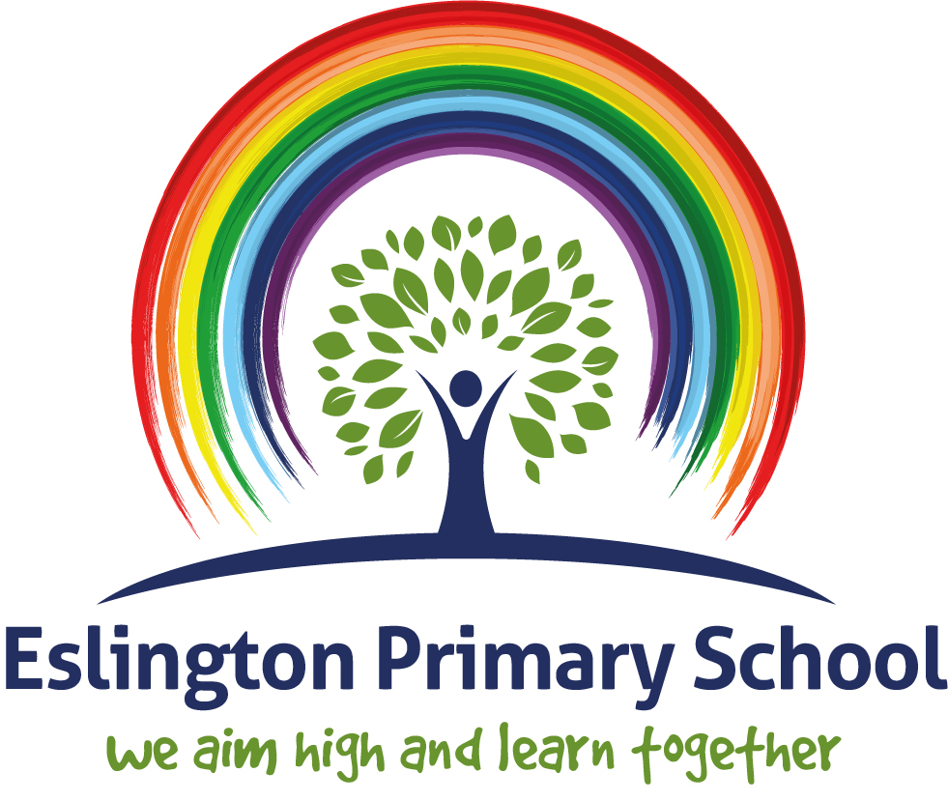
English Policy

2023-24

Eslington Primary School
English Policy
Eslington is a primary school for pupils across the borough of Gateshead who have an Education, Health and Care Plan (EHCP) for Social, Emotional and Mental Health needs (SEMH), with approximately 50% also having a secondary need of Autism Spectrum Condition (ASC). Many of our pupils have complex lives and are involved with various outside agencies, such as Social Services, the Speech and Language Team (SaLT) and the Children and Young Peoples Service (CYPS). Some of our pupils are subject to a Child Protection plan and some are identified as Looked After Children. Around 70% of our pupils are classed as Pupil Premium and many of the ways that we use the funding attached to this is through the teaching and learning we provide.
Typically, pupils arrive at our school with many gaps in their learning due to disruptions to their education caused by the impact of their SEMH needs. Prior to joining Eslington, children have often been on reduced timetables and frequently kept away from whole class teaching. Generally speaking, our pupils have not previously been exposed to consistently high-quality teaching from a qualified teacher. Previous schools have done their best to use their resources to meet the needs of the child, but it is usually not until they move to Eslington that they begin to receive full-time teaching and learning opportunities.
With this in mind, we have no time to waste and endeavour to seize every available learning opportunity in order to fill gaps in prior learning effectively and efficiently so that pupils can begin to make excellent progress.
Many of our pupils are working below age related expectations, but that is not a reflection of their ability, rather it indicates the impact of a history of disruptions in their education. Our pupils are bright, capable and eager to learn and it is our job to nurture that to the best of our abilities.
This document is a statement of the aims, principles and strategies for the teaching and learning of English at Eslington Primary School. It contributes to the school’s philosophy of teaching and learning as expressed through the Teaching and Learning Policy. This policy was created in October 2023 in light of our school priority of improving the quality of teaching and learning of English across the school.
Special educational needs & disabilities (SEND):
Eslington Primary School is a specialist provision for boys and girls in EYFS, Key Stages 1 & 2. All of the pupils that attend Eslington Primary School have an Education, Health and Care Single Plan which identifies social, emotion and mental health difficulties as their primary need.
Daily phonics, guided reading, handwriting and English lessons are inclusive to pupils with special educational needs and disabilities. Where required, children’s learning plans incorporate suitable objectives from the National Curriculum for English or Development Matters and teachers keep these in mind when planning work. These targets may be worked upon within the lesson as well as on a 1:1 basis outside of the lesson. English focused intervention in school helps children with gaps in their learning. These are delivered by trained support staff and overseen by the SENCO and/or the class teacher.
Within the daily English lesson teachers have a responsibility to not only provide differentiated activities to support children with SEND but also activities that provide sufficient challenge for children who are average and high achievers in line with mainstream expectations, delivery and outcomes. It is the teachers’ responsibility to ensure that all children are challenged at a level appropriate to their ability.
Equal Opportunities:
Equal opportunities lie at the heart of all that we do at Eslington Primary School. We are committed to ensuring that every member of the school community, whatever their position, race, gender, disability or religion is given the same chance as any other to access the services and support of the school.
The aim is to ensure that everyone makes progress and gains positively from lessons and to plan inclusive lessons. Lessons involving lots of visual, aural and kinaesthetic elements will benefit all children including those for whom English is an additional language (EAL) and language difficulties.
Teaching, questioning and level of support is differentiated so that the children are all working towards the same learning objective appropriate to their age group.
Rights Respecting Ethos:
The United Nations Convention on the Rights of the Child (CRC) is at the heart of our school’s planning, policies, practice and ethos. As a rights-respecting school we not only teach about children’s rights but also model in action rights and respect in all our relationships. Everyone within the school community has rights which are based on our aims and ethos and these have been further informed through the United Nations Convention on the Rights of the Child (UNCRC).
These rights are:
- To be safe
- To be heard
- To have beliefs
- To receive support
- To be treated with respect and dignity
- To learn/teach
Aims and objectives:
At Eslington Primary School, we believe to read and write is fundamental to our children succeeding; enabling them to access the next stage of their education and beyond. Our children have often been deprived of early literature and a wealth of vocabulary; it is therefore our job to teach them the skills linked to writing which intertwine with an enriched reading curriculum.
At Eslington Primary School we strive for all of our children to be literate. By the end of Year 6 we aim for all children to be able to:
- be effective, competent communicators and good listeners;
- express opinions, articulate feelings and formulate responses to a range of texts both fiction and non-fiction using appropriate technical vocabulary;
- foster an interest in words and their meanings, and to develop a growing vocabulary in both spoken and written form;
- have an interest in books and to read for enjoyment, engaging with and understanding a range of text types and genres;
- be able to write in a variety of styles and forms showing awareness of audience and purpose;
- develop powers of imagination, inventiveness and critical awareness in all areas of literacy;
- use grammar and punctuation accurately;
- understand spelling conventions;
- produce effective, well-presented written work.
Implementation
In the National Curriculum for 5 - 11-year olds, English is developed through four key areas:
- Spoken Language,
- Reading – Word Reading & Comprehension
- Writing – Transcription & Composition
- Spelling, Vocabulary, Grammar & Punctuation
It is important to note that each is closely interrelated with the next, so it becomes increasingly difficult to consider one without the other.
Foundation Stage
English in Early Years is based upon the Foundation Stage Profile strand of Communication, Language & Literacy. Communication, language and literacy depend on learning and being competent in a number of key skills, together with having the confidence, opportunity, encouragement, support and disposition to use them. This area of learning includes communication, speaking and listening in different situations and for different purposes, being read a wide range of books and reading simple texts and writing for a variety of purposes.
To give all children the best opportunities for effective development and learning in communication, language and literacy, practitioners should give particular attention to:
- Providing opportunities for children to communicate thoughts, ideas and feelings and build up relationships with adults and each other
- Incorporating communication, language and literacy development in planned activities in each area of learning;
- Giving opportunities to share and enjoy a wide range of rhymes, music, songs, poetry, stories and non-fiction books
- Giving opportunities for linking language with physical movement in action songs and rhymes, role play and practical experiences
- Planning an environment that reflects the importance of language through signs, notices and books
- Providing opportunities for children to see adults writing and for children to experiment with writing for themselves through making marks, personal writing symbols and conventional script
- Providing time and opportunities to develop spoken language through conversations between children and adults, both one-to- one and in small groups, with particular awareness of, and sensitivity to, the needs of children for whom English is an additional language, using their home language when appropriate.
Key Stage One
Children should learn to speak confidently and listen to what others have to say. Depending on their level of need and previous learning experiences, children should begin to read and write independently and begin to develop enthusiasm. They should use language to explore their own experiences and imaginary worlds.
Key Stage Two
Children should learn to change the way they speak and write to suit different situations, purposes and audiences. They should read a range of texts and respond to different layers of meaning in them. They should explore the use of language in literary and non-literary texts and learn how the structure of language works. Our curriculum is specific to each child and their learning stage. Therefore, children in Key Stage Two may need to follow Key Stage One curriculum due to circumstances within previous education settings.
Phonics Teaching
We follow the Read, Write, Inc phonics scheme. All children are assessed and then grouped according to phonic ability each term. Children who take part in Read Write Inc. receive targeted sessions on a daily basis and are assessed regularly. ‘Fresh Start Phonics’ is used as an intervention programme in KS2.
Independent Reading
Children engage in independent, sustained reading during short bursts throughout the school day. It provides an opportunity for pupils to read and enjoy a range of texts and to apply reading strategies. Each class has a dedicated, exciting reading area containing a range of books and text types for children to access independently.
Every class should have a range of books including:
- Poetry / plays
- Fiction – the choice of books reflects the spread of interest and reading abilities across the class, for example picture books, graphic novels, etc
- Non-fiction – as wide a range as possible, including plenty linked to the subject areas being studied
- Books from a range of cultures and covering a range of themes are interwoven through all collections
Books Going Home (Oxford Reading Tree, Accelerated Reader, Read Write Inc.):
EYFS, KS1 and KS2: Children are heard reading independently by an adult or their peers on a regular basis, changing their books when required. Children work their way through the stages according to their ability, progressing to reading literature of their choice (checked for suitability by an adult where necessary). The children will then test their comprehension skills using Accelerated Reader Quizzes. Pupils accessing phonics will also have a decodable phonics book, in-line with their current phonics group.
Writing
The programmes of study for writing at Key Stages 1 and 2 are constructed similarly to those for reading:
- transcription (spelling and handwriting)
- composition (articulating ideas and structuring them in speech and writing).
As a school, we follow the Talk for Writing approach to teaching writing, which breaks down the writing process into 3 sections: Imitation, Innovation and Invention (see Whole-school long term writing plan for a breakdown of our writing approach in different key stages).
Writing at Eslington Primary School is developed through:
Shared Writing
This provides an opportunity for teachers to demonstrate writing, including the thought processes that are required. Teachers should make explicit references to genre features, as well as word and sentence level work within the context of writing. Pupils contribute to the class composition by sharing their ideas with whole class, partners, in small groups or using individual white boards. This is also the time when children are given the opportunity to discuss, verbalise and refine ideas before committing to print. With knowledge of the text type from shared reading sessions, children should be able to generate a list of features that they would expect to use in any writing genre about which they have learned. This can be used by teachers and children alike as one way of assessing children’s writing and their understanding of the purpose and organisation.
Guided Writing
Children are given the opportunity to work as part of a small group to complete a piece of writing with the support and guidance of their teacher and peers. The group work together to begin a piece of writing and then continue independently whilst the teacher moves around the group and supports with individual needs as they arise. It is important that guided writing sessions are used with the range of abilities and learning needs represented across the classroom and are planned carefully according to children’s targets from their Pupil Profiles and EHCP to promote progression in writing skills for all children.
Independent Writing
Children should be given the opportunity for a range of independent writing activities which clearly link to whole class writing objectives. These tasks will need an identified audience, clear purpose and should cover all aspects of the writing process. Children should be given the opportunity to self-assess and peer-assess writing, based on a rubric linked to the learning objective and developed by the class as a whole as part of the teaching sequence leading up to creating an extended piece of writing. Ideally, time to mark pupil’s writing should be built into the lesson, as ‘live marking’ allows children to go through their work with an adult, learning from their misconceptions and understanding their targets for future pieces of writing. As a school, we build in regular cross-curricular writing opportunities, using our rich and varied curriculum as an engaging stimulus for the children.
Handwriting and Presentation
At Eslington, children are taught to write legibly, fluently and at a reasonable speed. In line with the National Curriculum guidance, we teach cursive writing once children are able to form their letters correctly in print.
The programmes of study for writing at Key Stages 1 and 2 are constructed similarly to those for reading:
- transcription (spelling and handwriting)
- composition (articulating ideas and structuring them in speech and writing)

A Connected Curriculum
At Eslington, we do not see English in isolation but connected with all other areas of learning. The children are encouraged to develop and apply their English skills in all other subjects and wherever possible a cross curricular approach is taken. This allows children to further practice new skills taken from their morning lessons. The high-quality texts chosen from Pi Corbett’s Reading Spine are used as a main driver for our lessons.
Monitoring and evaluation
The monitoring of the standards of children’s work and of the quality of teaching in English is the responsibility of the English subject leader. The subject leader has specially-allocated, regular management time in order to review evidence of the children’s work and lesson observations of English teaching across the school are planned in to the school calendar by the Senior Leadership Team. The subject leader will monitor and evaluate the subject systematically, focusing on different aspects of English each term. This also includes meeting with Governors and sharing information at the Governor meetings.
How do we measure the impact of English teaching?
At Eslington, we formatively assess children using assessment focuses provided by the Local Authority, we use targets from each individual child’s EHCP and are provided targets from NGRT testing each year. We make termly formal assessments to measure progress against the key objectives, and to help us plan the next unit of work.
The following tools are used in the assessment of English:
- Quality marking and feedback
- Termly teacher assessments which are in line with the Nation Curriculum
- Read Write Inc Phonic online assessments which take place termly
- NGRT Assessments
- Single word spelling tests (SWST)
- Book bands which correlate with both phonics and guided reading
- Early Years Foundation Stage assessment grids
- Teacher Assessment Frameworks for Y2 & Y6
Role of the Subject Leader
- To have an impact on raising standards of attainment for English across the whole school.
- Adapt and use the Programme of Study for English across the whole school that meets the needs of our children.
- To monitor the whole school and individual needs to be able to assess individual professional development opportunities and needs.
- To maintain the availability of high-quality resources.
- To maintain an overview of current trends and developments within the subject.
- To ensure, together with the Head Teacher, Senior Leadership Team, Assessment Lead and Curriculum Lead, a rigorous and effective programme of moderation of assessments.
- To ensure a regular and effective programme of analysis of children’s work sample monitoring is in place.
- To ensure a regular and effective programme of analysis of short-term planning is in place.
Class Teachers
- Ensure the effective implementation of the New National Curriculum for English.
- Adapt and use the Programme of study for English across the whole school that meets the needs of our children.
- Make effective use of Assessment for learning within English.
- To ensure work is planned to enable all children to reach their full potential.
Teaching Assistants
- To support the class teacher in the effective implementation of English.
- To support with phonics groups either 1:1 or smaller ratios
Parents/Carers
We believe that parents have a fundamental role to play in helping children to learn. We do all we can to inform parents about what and how their children are learning by:
- Holding parents’ consultation meetings to discuss children’s progress
- sending an annual report to parents in which we explain the progress made by each child and indicate how the child can develop their learning
- explaining to parents how they can support their children with homework and English learning
- sharing new learning with parents on ‘Seesaw’, an app which allows clear communication between home and school.

