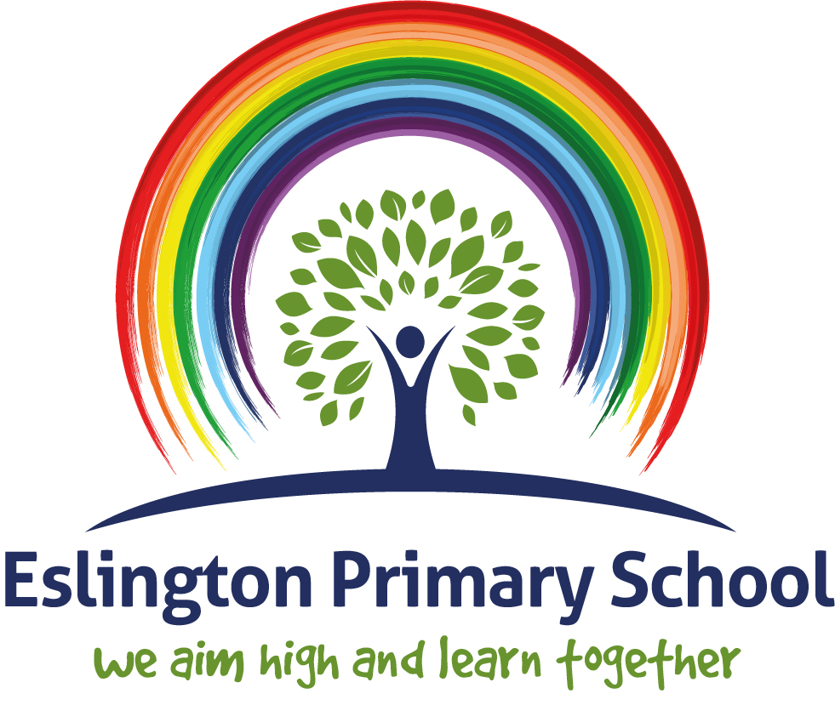

Music Policy

2023

Rationale

Music is a rich and inspirational art which brings lifelong engagement, enjoyment and education. It can offer personal development, friendship and employment opportunities and is inclusive to all.
Eslington School aims to give all children the opportunity to engage with music. Research has shown that children that engage in an expressive art form find it beneficial to development academically, emotionally and socially.

“Music is a universal language that embodies one of the highest forms of creativity. A high-quality music education should engage and inspire pupils to develop a love of music and their talent as musicians, and so increase their self-confidence, creativity and sense of achievement. As pupils progress, they should develop a critical engagement with music, allowing them to compose, and to listen with discrimination to the best in the musical canon.”
National Curriculum Music (2014)

The rationale of the Music curriculum at Eslington Primary School is that:

- Music is a subject that helps to develop creativity, imagination, good listening skills, constructive criticism and the ability to express personal thoughts and feelings.
- Music develops children’s ability to take part in practical activities, both individually and in groups, that encourages and cultivates an enjoyment of different genres of music.
- The Music curriculum provides breadth and balance, is relevant and engaging and is differentiated to match needs and abilities.

Eslington Primary School’s Rights Respecting Ethos
The United Nations Convention on the Rights of the Child (CRC) is at the heart of our school’s planning, policies, practice and ethos. As a rights-respecting school we not only teach about children’s rights but also model in action rights and respect in all our relationships. Everyone within the school community has rights which are based on our aims and ethos and these have been further informed through the United Nations Convention on the Rights of the Child (UNCRC).
These rights are including:
- To be safe
- To be heard
- To have beliefs
- To receive support
- To be treated with respect and dignity
- To learn/teach
This policy supports all children's rights especially:
Article 28: Every child has the right to an education. Primary education must be free. Secondary education must be available for every child. Discipline in schools much respect children's dignity. Richer countries must help poorer countries achieve this.
Article 31: Every child has the right to relax, play and take part in a wide range of cultural and artistic activities.

Music and Mental Health
Listening to music and playing an instrument improves Mental Health and wellbeing. It has long been recognised that Music is good for you, and in 2011, researchers found that music releases dopamine, the feel-good chemical in your brain. It also found that dopamine was up to 9% higher when volunteers listened to music that they enjoyed. It may be obvious to us, but it is strong evidence for the link between music and mental wellbeing.
https://bebrainfit.com/music-brain/

What are the mental effects of music?

The benefits to pupils of participating in musical activity in terms of their wellbeing are well-known. Sheffield University’s music department has a specific research group dedicated to wellbeing; many mainstream and special schools fund music therapy sessions and music is a staple of youth work and mental health projects. The charity Mind devote a page of their website to the benefits of music to mental health.
Because of its rhythmic and repetitive aspects, music engages the neocortex of our brain, which calms us and reduces impulsivity. We often utilize music to match or alter our mood

The main aim:
The national curriculum for music aims to ensure that all pupils:

“perform, listen to, review and evaluate music across a range of historical periods, genres, styles and traditions, including the works of the great composers and musicians”
National Curriculum Music (2014)
At Eslington Primary School:
- We want every child to fully develop their music potential through a high-quality, inspirational and enjoyable music education from the Early Years through to Y6 and beyond.
- We want all children to be musically confident and to have a good understanding of the elements of music.
- We want all children to enjoy taking part in singing activities and to have a positive experience of playing musical instruments.
- We want all children to develop active listening and the ability to evaluate and discuss what they hear.
- We want all children to feel confident and skilled to create their own music and to communicate with others through music.
- We would like all children to feel inspired and determined to continue their music making and listening experiences once they leave primary school.

Our School staff aim to do this by:
- Promoting a confident, positive attitude towards the learning and use of Music, making it an enjoyable experience.
- Promoting confidence and competence in the skills of speaking and listening; constructive feedback and sharing practical work.
- Providing opportunities for the development of musical skills where relevant across the curriculum.

Our Parents and Carers aim to do this by:
- Understanding and supportive of our aims in learning and teaching Music.
- Attending and contributing to Teacher Consultation Meetings.
- Praising their children for the good things that they do in Music.
- Communicating and working with the school whenever further support is needed to develop their children’s musical skills and understanding.

Subject Leader
The role of the Subject Leader is to provide professional leadership and management for a subject in order to secure high quality teaching, effective use of resources and high standards of learning and achievement for all pupils. They will achieve this by affecting the following key areas:
- Strategic direction and development.
- Learning and teaching.
- Leading and managing staff.
- Efficient and effective deployment of staff and resources.
The Subject Leader has regular discussions with the Head of School and other senior leaders about learning and teaching in Music. They will regularly reflect on the music delivery and adapt planning and leading.

National Curriculum for Music
Through our aims listed above and through our music scheme, we are able to meet the requirements of the National Curriculum for Music which are:
- Perform, listen to, review and evaluate music across a range of historical periods, genres styles and traditions, including the works of the great composers and musicians.
- Learn to sing and to use their voices, to create and compose music on their own and with others, have the opportunity to learn a musical instrument, use technology appropriately and have the opportunity to progress to the next level of musical excellence.
- Understand and explore how music is created, produced and communicated, including through the inter-related dimensions: pitch, duration, dynamics, tempo, timbre, texture, structure and appropriate musical notations.

Every class should aim to have at least one music lesson a week inspired by our school music curriculum.

Over time these lessons will develop children’s singing skills, listening skills and understanding of the elements and genres of music. These lessons will also help children to become confident to participate in a range of music activities including composition and instrumental lessons.
- Wherever possible, cross-curricular links are made with music and other subjects.
- Each Key Stage has a daily singing time during breakfast, assemblies and after lunch.
- We encourage staff to attend music CPD and have whole staff training sessions in school organised in partnership with Gateshead Schools’ Music Service.
- The schemes of work we use allow progression and differentiation so that children of all abilities are able to access the Music curriculum and develop their skills.

Support from Gateshead Music Service:
Gateshead Music Service offers an above and beyond ‘curriculum’ for some of our pupils. we will have two pathways in which we can offer additional tuition. As a result of the instrumental tuitions we aim to provide a small group tuition in a wide range of instruments is offered to all children. This is provided in partnership with Gateshead Schools’ Music Service and takes place every Wednesday afternoon.

The ‘Charanga’ resource
Charanga Musical School has been developed to allow teachers maximum flexibility. The Units of Work, themed Topics and instrumental Courses can be combined in the best way to suit your children and the whole school curriculum. It is essential that the children cover all aspects of the curriculum through the Key Stage although there may be times when you wish to focus on a specific aspect eg First Access, whole-class ensemble work or a seasonal performance. Charanga offers all teaching staff medium term planning as to what is taught within Music teaching units. It also offers short term plan lists with specific learning objectives that are to be covered and success criteria to support both children and adults in assessing their work. All teaching and learning is differentiated to best match the needs of the class or set and the individuals within it; within the context of the aspect of Music that is being taught.

Resources
Music resources are many and varied, including:
- A large selection of tuned and un-tuned percussion instruments;
- Other instruments including guitars, keyboards, recorders etc;
- The ‘Charanga’ scheme of work (FS to Year 6);
- A range of song books, CDs, etc.;

Homework
- Music Homework is set for children in Years 1-6 at relevant times during the year.
- Homework provides opportunities for children to;
a) Practice and consolidate their skills and knowledge;
b) develop and extend their techniques and strategies;
c) prepare for their future learning through out of class activities and homework.

Music Units of Work
- A progression of lessons will be planned over a five or six week blocked unit of work that is taught over a half term.
- The Music units of work will be taught during alternate half terms alongside the modern foreign language curriculum.

Music across the Curriculum
Children are taught a wide range of musical skills that enable them to access and understand different types of music in a variety of contexts, both within school and at home.

- Opportunities are used for musical experiences through a range of activities in other subjects to enable children to apply and use Music in real life and academic contexts.
- Music is incorporated into a variety of activities and events within school, such as weekly assemblies, singing assemblies, classroom routines and special celebrations.
- We have regular concerts showcasing singing and instrumental performances e.g. Christmas performance, harvest festival, Easter performance etc.
- We take part in local singing events such as the Spring Sing and Big Sing.
- We offer children the chance to experience live music through music workshop visits to school and visits to local concert halls and other venues
- We encourage children who are taking instrumental lessons to join a local ensemble. This is facilitated in partnership with Gateshead Schools’ Music Service.

Assessment, Record Keeping and Reporting
- We are building a record of music at our school through a diary of provision, events, achievements, participation, performances and staff training. This is supplemented with recordings, photographs and informal observations.
- Children’s standards and achievements in Music are assessed in line with the School’s Assessment Policy. On-going Assessment for Learning (AfL) practices within class and group sessions, including the sharing of and reference being made to Learning Objective and Success Criteria and self and peer assessments of understanding, outcomes and progress.
- Children are assessed against the National Curriculum targets as working towards, achieving and working at greater depth and music is reported on at the end of each academic year in each child’s school report.
- Music is reported on at the end of the academic year in each child’s School Report.
- At the end of each term pupils will get the option to perform what they have learnt in their music lessons in front of an audience. This is then used as evidence to assess their ability in music.
- All childrens performances and skills are recorded on SeeSaw.

Inclusion
Inclusion is about the school ensuring that every child can actively participate and progress their learning.

- Successful inclusive provision at Eslington is seen as the responsibility of the whole school community, permeating all aspects of school life and applicable to all our pupils.
- Inclusive practice in Music should enable all children to achieve their best possible standard; whatever their ability, and irrespective of gender, ethnic, social or cultural background, home language or any other aspect that could affect their participation in, or progress in their learning.
- Children that are ‘talented’ will be given the opportunity to work with the Music Subject Leader to prepare pieces of music to be performed in assemblies; as individual items and also as background music whilst children enter and leave the hall.

Monitoring and Review
The Headteacher and Music Subject Leader will monitor the effectiveness of this policy on a regular basis. The Headteacher and Music Subject Leader will report to the governing body on the effectiveness of the policy annually and, if necessary, makes recommendations for further improvements.

