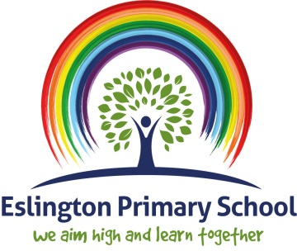

Personal, Social, Health and Economic Education Policy

September 2023

1. Introduction
The ethos of Eslington Primary School is to enable every pupil aged 3 - 11 years with Social, Emotional and Mental Health difficulties (SEMH) to experience an enjoyable, happy and caring learning environment. It is intended that each pupil develops their full potential irrespective of their needs, ability, disability, race or gender.
Eslington Primary School is a maintained primary school for pupils from the ages of 3 to 11 years. It caters for pupils with Social, Emotional and Mental Health (SEMH) needs. In addition, pupils might have other needs such as Autistic Spectrum Condition (ASC), Dyslexia, Attachment Difficulties, Attention Deficit Hyperactivity Disorder (ADHD), Speech and Language, Pathological Demand Avoidance (PDA) etc and these needs are met by the skilled staff within school. Pupils are placed in the schools by the Special Educational Needs and Disability Team at Gateshead Council. As a school, we have a duty to promote children and young people’s wellbeing. Wellbeing is defined in the Children Act 2004 as the promotion of physical and mental health; emotional wellbeing; social and economic wellbeing; education, training and recreation; recognition of the contribution made by children to society and protection from harm and neglect. We also have a duty to promote community cohesion (Education and Inspections Act 2006; Education Act 2002).
This policy builds upon the mission statement:
‘We aim high and learn together’
This policy also recognises our Rights Respecting Ethos.

Rights Respecting Ethos
The United Nations Convention on the Rights of the Child (CRC) is at the heart of our school’s planning, policies, practice and ethos. As a Rights-Respecting school we teach an understanding of children’s rights and continually model mutual respect and promote an awareness of pupils’ rights. Everyone within the school community has rights, upon which we base our aims and school ethos. These have been further informed by the United Nations Convention on the Rights of the Child (UNCRC).
These rights are:
- To be safe
- To be heard
- To have beliefs
- To receive support
- To be treated with respect and dignity
- To learn/teach.

2. Aim of this policy
This policy has been formulated by the Senior Leadership Team and PSHE co-ordinator after consultation with the Local Authority’s Sex and Relationship Team and following the guidelines as set out in the DfE document 0116/2000. This policy reflects the needs and opinions of pupils, parents and stakeholders and reflects that pupils can join the school at any time during the academic year.

3. What is PSHE about?
Personal, Social, Health and Economic Education (PSHE) is a wide-ranging subject encompassing many issues including health and wellbeing, sex education, personal and social relationships, keeping safe and issues of moral and ethical values. It encourages pupils to make decisions and develop positive attitudes so that they can become healthy, happy and secure adults. Effective PSHE is vital to ensure that pupils grow up able to enjoy the positive benefits of loving, rewarding and responsible relationships. At Eslington Primary school, PSHE is at the centre of all teaching and learning and includes all aspects of school life. As part of a whole school approach, PSHE education develops the qualities and attributes pupils need to thrive as individuals, family members and members of society.
PSHE at Eslington Primary school covers the Health Education and Relationship and Sex Education curriculum that became statutory in all maintained primary schools in September 2021. Health Education focusses on how to maintain physical health and mental wellbeing including simple self-care techniques, personal hygiene, prevention of health and wellbeing problems and basic first aid. Relationships and Sex Education (RSE) is all about learning the emotional, social and physical aspects of growing up, relationships, sex, human sexuality and sexual health. Some aspects of this are taught in science, and others are taught as part of PSHE. A comprehensive programme of RSE provides accurate information about the body, reproduction, sex, and sexual health. It also gives children and young people essential skills for building positive, enjoyable, respectful and non-exploitative relationships and staying safe both on and offline. RSE involves a combination of sharing information and exploring issues and values and is not about the promotion of sexual activity.

4. Statutory guidance
At Eslington Primary school, we do not have to follow the National Curriculum but we are expected to offer all pupils a curriculum that is similar to the National Curriculum including requirements to teach science which would include the elements of sex education contained in the science curriculum.
In teaching PSHE, we are required by our funding agreements to have regard to guidance issued by the Secretary of State for Education as outlined in section 403 of the Education Act 1996. This states that Eslington Primary School has a statutory duty which all schools are required to meet: ‘Every state-funded school must offer a curriculum which is balanced and broadly-based and which:

· promotes the spiritual, moral, cultural, mental and physical development of pupils at the school and of society.
· prepares pupils at the school for the opportunities, responsibilities and experiences of later life.

The Education Act 1996, as amended by the Learning and Skills Act 2000, requires headteachers and governing bodies to have regard to national guidance on PSHE in schools and to protect children from unsuitable teaching and materials. Under the Children Act 2004, schools have a duty to promote the well-being of their pupils and good quality PSHE contributes to this duty.
Further, we recognise that as a school we have a responsibility under The Relationships Education, Relationship & Sex Education and Health Education (England) Regulations 2019, made under sections 34 & 35 of the Children & Social Work Act 2017, to provide comprehensive Relationship Education and Health Education for all pupils receiving primary education. The law requires that Relationships and Sex Education (RSE) is to be taught in all secondary schools in England, and that Relationships Education is to be taught in all primary schools in England. Health Education will also be mandatory in all Government-funded schools, which includes content on puberty.
Health Education in Primary schools is statutory. This consists of x35 outcomes (DfE guidance pages 32-35, See Appendix 2) that pupils should know ‘by the end of primary school’. This includes outcomes relating to understanding puberty, and as such, parents are unable to opt out of their child receiving puberty education.
Relationships Education in Primary schools is statutory. This consists of 32 outcomes (DFE guidance pages 20-21, see Appendix 3) that pupils should know ‘by the end of primary school’. The outcomes are not broken down into what should be taught when, so schools need to decide how to build these into a spiral, age-appropriate scheme of work.
Sex Education at Primary level is NOT statutory within RSE or Health Education, though Primary schools are still required to teach the elements of sex education contained in the science curriculum. “Sex Education is not compulsory in primary schools” although, “the Department continues to recommend…that all primary schools should have a sex education programme tailored to the age and the physical and emotional maturity of the pupils” (DFE page 23).
Where a maintained primary school chooses to teach aspects of sex education (which go beyond the national curriculum for science), the school must set this out in their policy and all schools should consult with parents on what is to be covered. All schools are legally obliged to have an up-to-date RSE Policy that describes the content and organisation of RSE taught outside the science curriculum.
A comprehensive PSHE programme can have a positive impact on pupils’ health and wellbeing and their ability to achieve and can play a crucial part in meeting these obligations.

5. What are the aims and objectives of our PSHE curriculum?
Our curriculum aims and objectives are:
- To support pupils to be wise and be safe. This means having the confidence to say NO to experiences that they do not want to engage in.
- To teach pupils the correct vocabulary to describe themselves and their bodies.
- To support and enhance the personal, social and emotional development of all pupils.
- To promote self-esteem, confidence and acknowledge the value of oneself and others.
- To challenge any potential bullying behaviour and views.
- To enable pupils to make secure, informed, personal and safe choices.
- To help pupils to develop skills of communication within relationships.
- To develop a positive self-image and confidence and ensure that pupils know they are responsible for and in charge of their own bodies.
- To provide knowledge about the developing body and process of reproduction and the nature of sexuality.
- To provide the opportunity to discuss feelings, perceptions, values and experiences.
- To be sensitive to the needs of our pupils in recognising their cultural backgrounds and experiences and that of the society they live in.
- To promote a positive and healthy attitude to sex by challenging stereotyping based on gender or sexuality.
- To appreciate the value of stable family life, commitment to a partner and the responsibilities of parenthood.
- To increase awareness of sources of information, help and support.
- Highlight vulnerability and risks to young people particularly regarding the potential for their exploitation.
- To respect pupils’ right to confidentiality and work with parents to support their understanding of this.

6. How is PSHE provided?
Pupils need to be given accurate information and support to develop skills to enable them to understand difference and respect themselves and others. A planned progressive programme of PSHE will gradually and appropriately begin to prepare pupils for adult life. It will support the teaching of skills that pupils require, to manage effectively the natural physical and emotional changes that they experience as they grow and mature into healthy, confident and independent adults.
Our curriculum is set out as per Appendix 1, but we may need to adapt it as and when necessary.
PSHE lessons will be delivered by the class teacher and on occasion, there will be input from external professionals who will work closely with the class team. Usually, pupils will work in mixed gender groups: however, there may be occasions when single gender groups are more appropriate and relevant.
In line with national recommendations PSHE is reinforced throughout the whole of the school day and gradually developed through the age range. Within our SEMH provision, we offer additional opportunities outside of structured lessons to further develop pupils’ personal, social and emotional skills.
The diagram below illustrates how PSHE is delivered across the whole school:
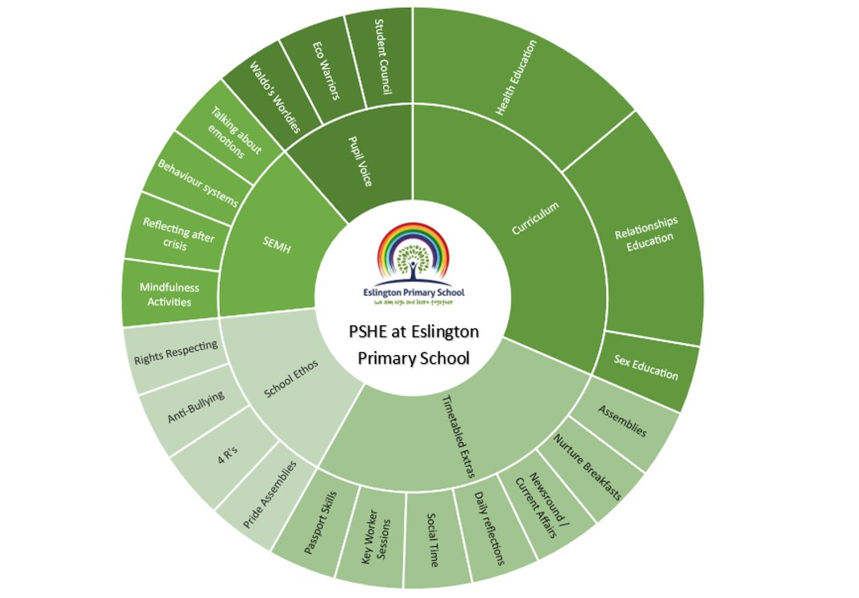
Curriculum
PSHE lessons are delivered in all classes four times a week. Teachers are skilled in delivering lessons that take into consideration all earning styles, and therefore lessons may include discussions, practical activities, debate and some written work where required. Lessons are planned and delivered following the Progression of Skills document detailed in Appendix 1.

Health Education focuses on the characteristics of good physical health and mental wellbeing, including:

- Mental wellbeing
- Internet safety and harms
- Physical health and fitness
- Healthy eating
- Drugs, alcohol and tobacco
- Health and prevention
- Basic first aid
- Changing adolescent body

Relationships education focuses on teaching the fundamental building blocks and characteristics of positive relationships including:
- Families and people who care for me
- Caring friendships
- Respectful relationships
- Online relationships
- Being safe

Non-statutory sex education lessons at Eslington Primary school covers any aspects of sexual reproduction that is not covered in science. This will involve helping children to understand the place of sexual intercourse within a consensual relationship and how this leads to the wonder of new life, as well as allowing children to ask any questions they may have and addressing any misconceptions. Parents will be informed by staff before this content is taught in school, with the option of opting out of this if they wish.
In addition to topics detailed within Eslington Primary’s schools curriculum, staff may deliver lessons, provide safe spaces for group chats in class or lead whole school assemblies in response to issues that may be pertinent to children at that time, or that have been raised as topics of interest.
Timetabled Extras
School Ethos
SEMH
Pupil Voice

7. How do we cover specific and sensitive issues related to PSHE?
A range of sensitive issues may inevitably be raised by pupils, if not by the teacher. Such issues will be addressed with sensitivity, at a level appropriate to the age and ability of the pupils, and in an objective manner free from personal bias. Account will be taken of different viewpoints and beliefs. Discussions will be set within the legal framework and pupils supported to understand the law as it relates to specific issues.

- Confidentiality: – teachers will respect confidentiality with the exception that where a course of action may place a pupil at moral or physical risk, the teacher has a responsibility to inform the Head of School or a member of the Senior Leadership Team. Pupils are made aware and reminded that teachers cannot promise total confidentiality. Pupils will be offered sensitive and appropriate support and absolutely encouraged to discuss what they have learned and further questions they may have, with their parents/carers.

- Child Protection procedures: – where a pupil discloses sexual abuse or where a teacher has reason to suspect abuse, immediate action will be taken to inform the school’s Designated Safeguarding Lead (DSL) and the school’s Child Protection policy and procedure will be followed.

- Advice to pupils: – where an individual pupil asks specific advice on aspects of sexual behaviour, they will be encouraged to seek advice from their parents. Pupils will also be given contact information of agencies where more support and advice can be obtained. Some services, NHS provisions etc have authority to speak to pupils based on health protocols and as such, operate a confidential service direct with pupils.

- Prevention of Sexual Violence and Harrassment: - schools play an important role in preventative education. Keeping Children Safe in Education sets out that all schools should ensure children are taught about safeguarding, including how to stay safe online. Addressing inappropriate behaviour can be an important intervention that helps prevent problematic, abusive and/or violent behaviour in the future. Children displaying harmful sexual behaviour have often experienced their own abuse and trauma. It is important that they are offered appropriate support. Eslington Primary School has a clear set of values and standards, and these will be upheld and demonstrated throughout all aspects of school life. These are underpinned in the school’s behaviour policy and pastoral support system, and by a planned programme of evidence-based content delivered through the whole curriculum. Eslington Primary School is a rights respecting school and follows the four R’s. These are explained below:
The Four R’s
- Respect for ourselves, each other, cultures, religions, the environment and the world in which we live.
- Responsibility- being responsible citizens for the future.
- Resilience – knowing that it is OK to fail. To have the ability to bounce back and try again.
- Relationships - to understand what a healthy relationship is and be able to inform productive, healthy relationships to support us through school and our future.
As part of a whole school approach for prevention, it is important to recognise that sexual harassment can have both short- and long-term consequences for victims and survivors which will appear differently for each individual, impacting mental health and wellbeing. Our PSHE/RSE curriculum is delivered for stage not age and several factors are covered to make sure that sensitive issues are tackled. These include recognising and maintaining healthy and respectful relationships, behaving in respectful ways, recognising and resisting pressure, seeking help, consent, managing risk, understanding acceptable touch, sexual harassment and sexual violence.
Furthermore, the RSE curriculum complements the school computing curriculum, teaching age restrictions on online platforms and educating the children on how to be safe online, how to manage social media apps and web platforms, online privacy (data protection) including how to use privacy settings on their most- used platforms (e.g. Instagram, Snapchat, Tiktok), and knowing how to identify fake profiles. It is emphasised to the children attending Eslington Primary School that all of these platforms have a age restriction over 11 years.
8. Organisation of our school’s RSE curriculum and teaching
- Staff training will involve a team-teaching approach where appropriate and information can be cascaded to other members of staff accordingly.
- A whole school approach will be applied with individual lessons on sex and relationships being taught within the PSHE programme using Health Promotions materials and specialist sexual health professionals.
- The programme will be planned and co-ordinated with the expectation that there will be space for discussion and that there is provision for pupils to work in small groups/with outside educators. Materials prepared by the teacher will be provided to all.
- Provision will be made for single sex teaching and individual follow up sessions as appropriate.
- Teaching staff will not be obliged to answer personal/controversial questions.
- The use of appropriate language will be always emphasised although ‘street language’ will be explored.
- Review: – the programme is evaluated by both staff and pupils using pro-forma covering attitudinal shift and knowledge on the subject.
- Resources will be appropriate according to the pupils’ interest, age and maturity.

9. What is the PSHE curriculum at Eslington Primary School?
We have developed the curriculum in consultation with parents, pupils and staff, considering the age, needs and feelings of pupils. If pupils ask questions outside the scope of this policy, teachers will respond in an appropriate manner, so they are fully informed and do not seek answers online.
Every year group will access some RSE within their curriculum. This can either be through subject taught lessons or through whole school assemblies, activities during the PSHE curriculum, off-site visitors or trips and by workshops led by external visitors.

Statutory Relationships education focuses on teaching the fundamental building blocks and characteristics of positive relationships including:
- Families and people who care for me
- Caring friendships
- Respectful relationships
- Online relationships
- Being safe

These areas of learning are taught within the context of family life, taking care to ensure that there is no stigmatisation of children based on their home circumstances. As outlined above, families can include single parents, LGBT parents, families headed by grandparents, adoptive parents, foster parents/carers etc and we need to be sensitive to the fact that some children may have a different support framework around them (for example: looked after children or young carers).

- Morals and values: the moral and values framework, which informs the teaching of sex education is reflected in the school’s aims and the ethos as defined in the SMSC Policy.

- Equal opportunities: all are treated equally. No one is excluded from having the opportunity to take part in the sex education programme. Parents can withdraw their children from sex education lessons by advising the school in writing. Access to information and support agencies is available to all pupils. Targeted single sex sexual health education is also offered now that girls attend the school. This allows an opportunity to equal access to information.

10. RSE policy overview and roles and responsibilities
The PSHE Co-ordinator and the Senior Leadership Team are responsible for monitoring the standards of pupils’ work and the quality of teaching. They are expected to support colleagues in the teaching of RSE by giving them information about current developments in the subject. Strengths and weaknesses in the subject and areas for further improvement are discussed with the Head of School and colleagues, and feedback is given to the governor responsible for PSHE and Citizenship.

The governing board
The governing body will approve the RSE policy and hold the Head of School to account for its implementation.

The Head of School
The Head of School is responsible for ensuring that RSE is taught consistently across the school, and for managing requests to withdraw pupils from [non-statutory/non-science] components of RSE.

Staff
Staff are responsible for:
- Delivering RSE in a sensitive way
- Modelling positive attitudes to RSE
- Monitoring progress
- Responding to the needs of individual pupils
- Responding appropriately to pupils whose parents wish them to be withdrawn from the [non-statutory/non-science] components of RSE.
Staff do not have the right to opt out of teaching RSE. Staff who have concerns about teaching RSE are encouraged to discuss this with the Head of School.

Pupils
- Pupils are expected to engage fully in RSE and, when discussing issues related to RSE, treat others with respect and sensitivity.

Parents’ right to withdraw
- Parents do not have the right to withdraw their children from relationships education.
- Parents have the right to withdraw their children from the [non-statutory/non-science] components of sex education within RSE.
- Requests for withdrawal should be put in writing using the form found in Appendix 1 of this policy and addressed to the Head of School.
- Alternative work will be given to pupils who are withdrawn from sex education.

Staff training/CPD
- The school is committed to improvements in the delivery of good quality RSE teaching and sees current and future training as important for those who deliver curriculum.
- Staff are responsible for liaising with the Head of School or a member of the Senior Leadership Team to identify areas in which they feel that they would require training: - a range of service providers are accessible to the school
- The PSHE Co-ordinator, in conjunction with the Head of School provides INSET training for the whole school.

Resource Provision
- The PSHE Co-ordinator is responsible for the purchasing of RSE resources
- Class teachers are required to also provide resources to help with cross curricular activities within their lessons that are linked to RSE.

Dissemination of the RSE Policy
- All members of staff will be given a full copy of the RSE policy
- All governors will receive a copy of the RSE policy
- Policies are available on the website to any other interested parents (e.g. parents, visitors, LA officers).

11. Monitoring and evaluating the RSE Policy
To monitor and evaluate the effectiveness of the policy and its implementation, the following steps will be taken:
- Pupil feedback
- Staff consultation
- Parent/stakeholder consultation
- Changes made to the school ethos in relationship to whole school PSHE curriculum.
- Changes to the science curriculum.
Yearly reviews will be made to recognise changes that may occur. This policy is reviewed annually.

Appendix 1: Eslington Primary School PSHE Curriculum Progression of Skills (topics in italics indicate RSE objectives)
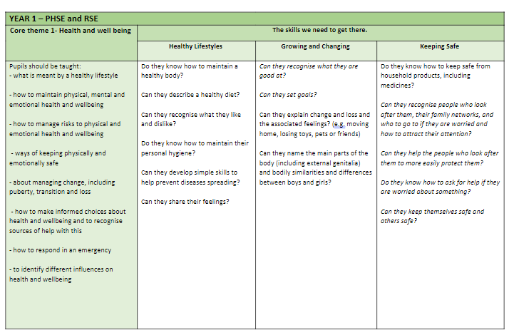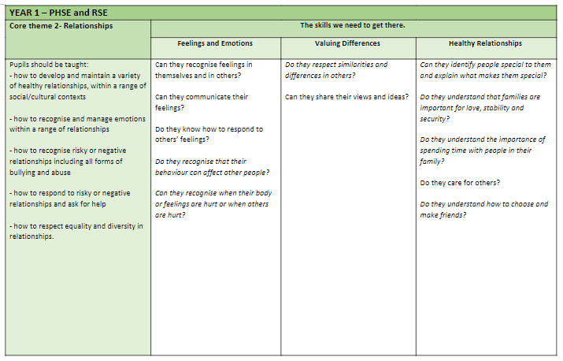
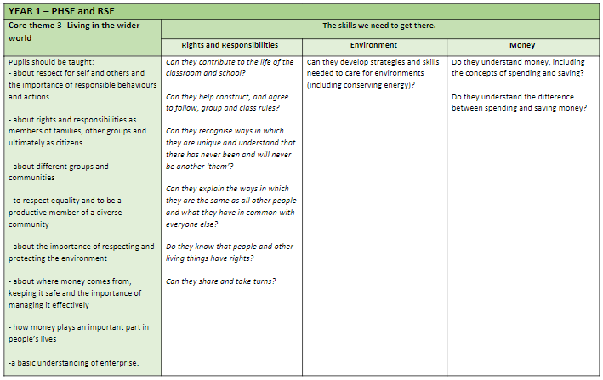
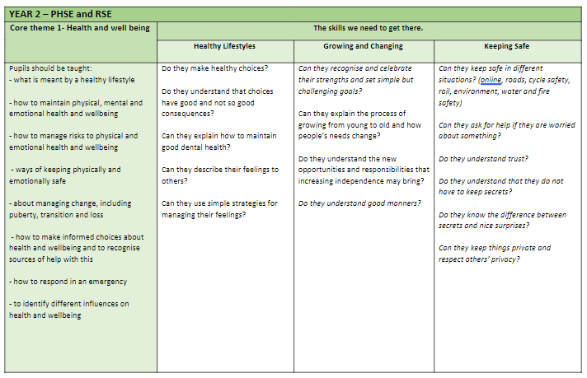
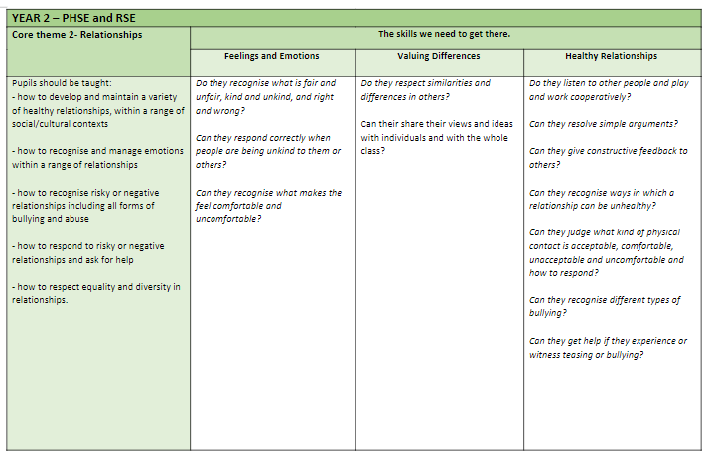
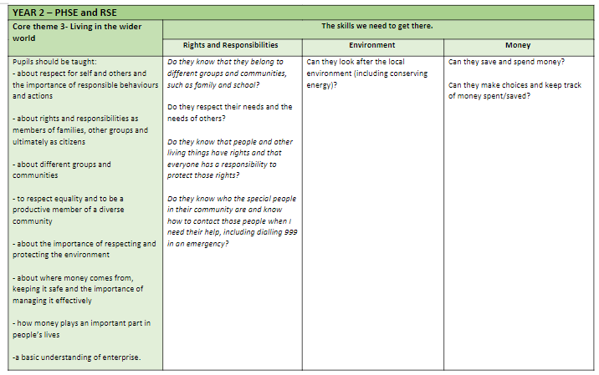
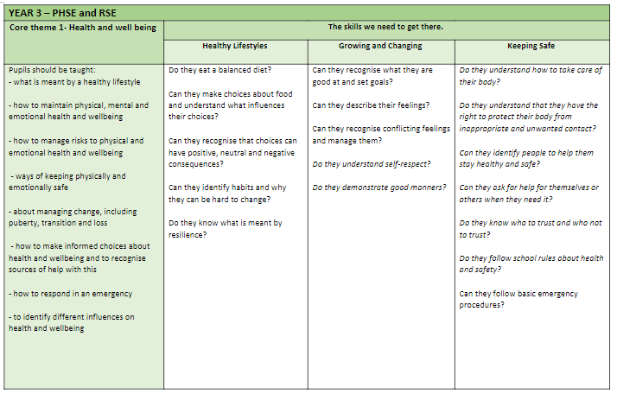
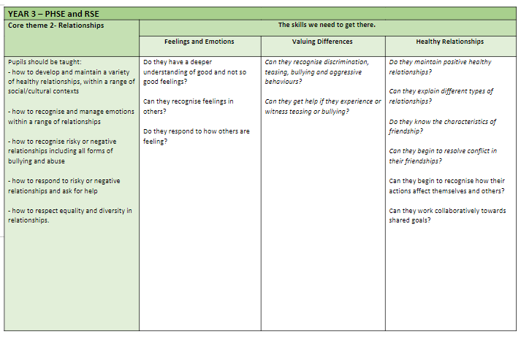
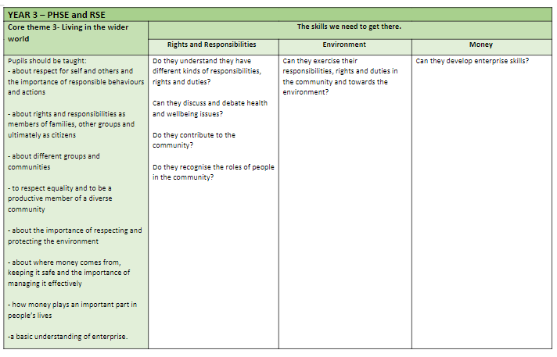
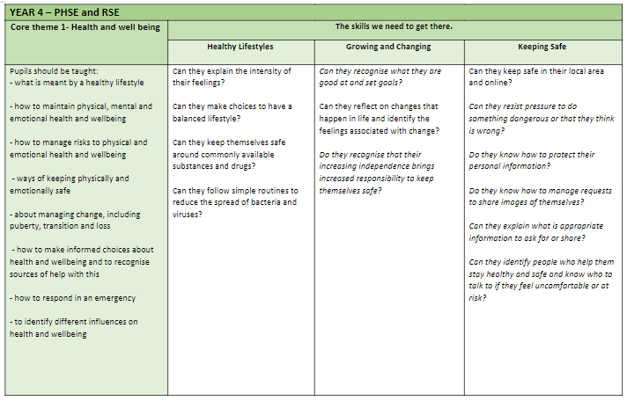
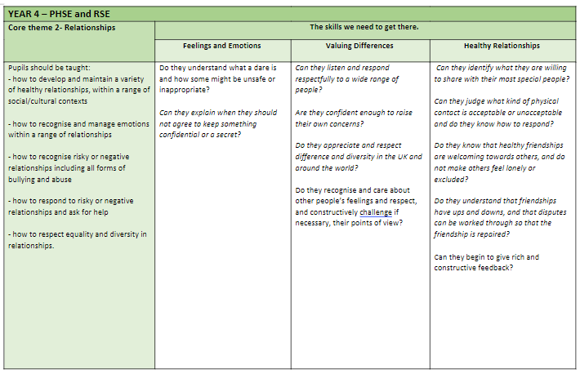
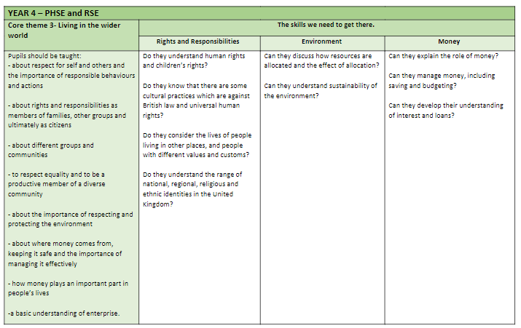
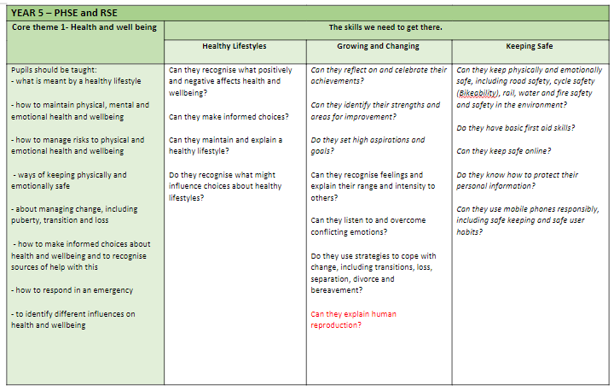
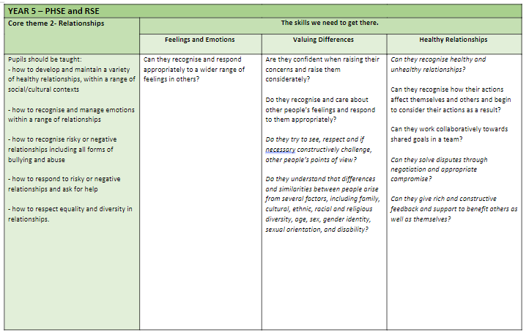
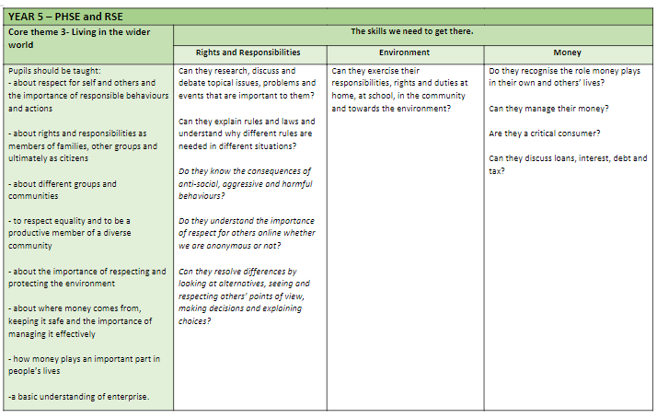
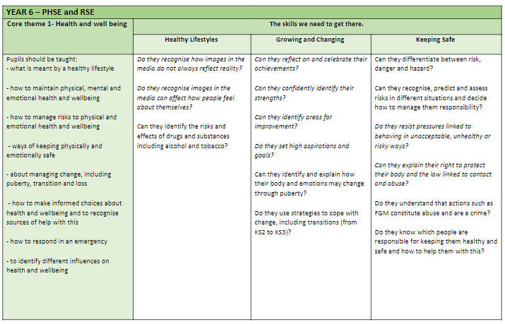
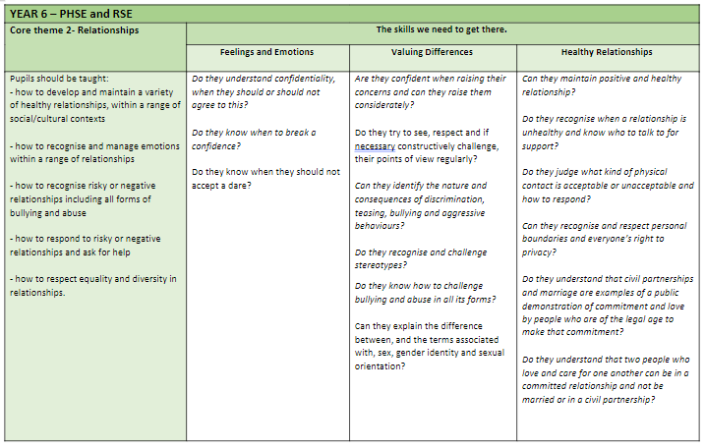
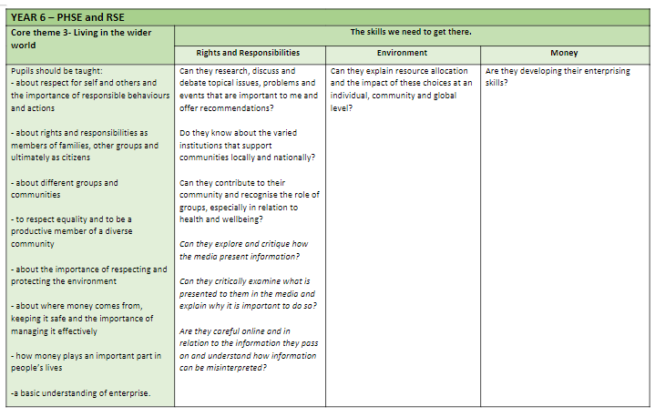

Appendix 3: DfE statutory Health Education targets by end of KS2, showing where they appear in our curriculum.
Topic | Pupils Should Know
Mental wellbeing | - That mental wellbeing is a normal part of daily life, in the same way as physical health. Y1 Healthy Lifestyles, Y1 Growing & Changing, Y1 F&E, Y2 Healthy Lifestyles, Y3 Healthy Lifestyles, Y3 Keeping Safe, Y3 F&E, Y3 R&R, Y4 Healthy Lifestyles, Y4 Growing & Changing, Y4 Keeping Safe, Y5 Healthy Lifestyles, Y5 Growing & Changing, Y5 Keeping Safe, Y6 Healthy Lifestyles, Y6 Growing & Changing, Y6 Keeping Safe, Y6 Healthy Relationships  - That there is a normal range of emotions (e.g. happiness, sadness, anger, fear, surprise, nervousness) and scale of emotions that all humans experience in relation to different experiences and situations. Y1 Healthy Lifestyles, Y1 F&E, Y2 Healthy lifestyles, Y2 R&R, Y3 Healthy lifestyles, Y3 Growing & Changing, Y3 F&E, Y4 Healthy lifestyles, Y4 Growing & Changing, Y4 Valuing difference, Y6 Growing & Changing, Y5 F&E, Y5 Valuing Difference, Y6 Growing & Changing  - How to recognise and talk about their emotions, including having a varied vocabulary of words to use when talking about their own and others’ feelings. Y1 Healthy Lifestyles, Y1 F&E, Y2 Healthy lifestyles, Y2 R&R, Y3 Healthy lifestyles, Y3 Growing & Changing, Y3 F&E, Y4 Healthy lifestyles, Y4 Growing & Changing, Y4 Valuing difference, Y6 Growing & Changing, Y5 F&E, Y5 Valuing Difference, Y6 Growing & Changing  - How to judge whether what they are feeling and how they are behaving is appropriate and proportionate. Y1 F&E, Y2 Healthy Lifestyles, Y5 R&R, Y5 Growing & Changing  - The benefits of physical exercise, time outdoors, community participation, voluntary and service-based activity on mental wellbeing and happiness. Y3 R&R, Y3 Environment, Y5 Environment, Y6 R&R,  - Simple self-care techniques, including the importance of rest, time spent with friends and family and the benefits of hobbies and interests.  - Isolation and loneliness can affect children and that it is very important for children to discuss their feelings with an adult and seek support. Y1 Keeping Safe, Y2 Keeping Safe, Y2 R&R, Y3 Keeping Safe, Y4 Keeping Safe, Y6 Keeping Safe  - That bullying (inc cyberbullying) has a negative and lasting impact on mental wellbeing. Y2 Healthy Relationships, Y3 Valuing Differences, Y6 Valuing Differences  - Where and how to seek support (including recognising the triggers for seeking support), including whom in school they should speak to if they are worried about their own or someone else’s mental wellbeing or ability to control their emotions (including issues arising online). Y1 Keeping Safe, Y2 Keeping Safe, Y2 R&R, Y3 Keeping Safe, Y4 Keeping Safe, Y6 Keeping Safe  - It is common for people to experience mental ill health. For many people who do, the problems can be resolved if the right support is made available, especially if accessed early enough.Y3 Rights & Responsibilities, Y5 Healthy Lifestyles, Y6 R&R
Internet safety and harms | - That for most people the internet is an integral part of life and has many benefits. Y2 Keeping Safe, Y4 Keeping Safe, Y5 Keeping Safe, Y6 R&R  - About the benefits of rationing time spent online, the risks of excessive time spent on electronic devices and the impact of positive and negative content online on their own and others’ mental and physical wellbeing. Y2 Keeping Safe, Y4 Keeping Safe, Y5 Keeping Safe, Y6 R&R  - How to consider the effect of their online actions on others and know how to recognise and display respectful behaviour online and the importance of keeping personal information private. Y2 Keeping Safe, Y4 Keeping Safe, Y5 Keeping Safe, Y6 R&R  - Why social media, some computer games and online gaming are age restricted. Y5 Keeping Safe, Y6 R&R  - That the internet can also be a negative place where online abuse, trolling, bullying and harassment can take place, which can have a negative impact on mental health. Y5 Keeping Safe, Y6 R&R  - How to be a discerning consumer of information online including understanding that information, including that from search engines, is ranked, selected and targeted. Y5 Keeping Safe, Y6 R&R  - Where and how to report concerns and get support with issues online. Y5 Keeping Safe, Y6 R&R
Physical health and fitness | - The characteristics and mental and physical benefits of an active lifestyle. Y4 Healthy Lifestyles, Y5 Healthy Lifestyles  - The importance of building regular exercise into daily and weekly routines and how to achieve this; e.g. walking or cycling to school, a daily active mile or other forms of regular, vigorous exercise.  - The risks associated with an inactive lifestyle (including obesity). Y3 Healthy Lifestyles  - How and when to seek support including which adults to speak to in school if they are worried about their health. Y1 Keeping Safe, Y2 Keeping Safe, Y2 R&R, Y3 Keeping Safe, Y4 Keeping Safe, Y6 Keeping Safe
Healthy eating | - What constitutes a healthy diet (including understanding calories and other nutritional content). Y1 Healthy Lifestyles, Y3 Healthy Lifestyles  - The principles of planning and preparing a range of healthy meals. Y1 Healthy Lifestyles, Y3 Healthy Lifestyles  - The characteristics of a poor diet and risks associated with unhealthy eating (including, for example, obesity and tooth decay) and other behaviours (e.g. the impact of alcohol on diet or health). Y2 Healthy Lifestyles, Y4 Healthy Lifestyles, Y6 Healthy Lifestyles
Drugs, alcohol and tobacco | - The facts about legal and illegal harmful substances and associated risks, including smoking, alcohol use and drug-taking. Y4 Healthy Lifestyles, Y6 Healthy Lifestyles
Health and prevention | - How to recognise early signs of physical illness, such as weight loss, or unexplained changes to the body. Y1 Healthy Lifestyles, Y4 Healthy Lifestyles, Y5 Healthy Lifestyles  - About safe and unsafe exposure to the sun, and how to reduce the risk of sun damage, including skin cancer. Y2 Keeping Safe, Y5 Keeping Safe  - About dental health and the benefits of good oral hygiene and dental flossing, including regular check-ups at the dentist. Y2 Healthy Lifestyles  - About personal hygiene and germs including bacteria, viruses, how they are spread and treated, and the importance of handwashing. Y1 Healthy Lifestyles, Y4 Healthy Lifestyles
Basic first aid | - How to make a clear and efficient call to emergency services if necessary. Y2 R&R, Y3 Keeping Safe  - Concepts of basic first-aid, for example dealing with common injuries, including head injuries. Y5 Keeping Safe
Changing adolescent body | - Key facts about puberty and the changing adolescent body, particularly from age 9 through to age 11, including physical and emotional changes. Y4 Growing & Changing, Y6 Growing & Changing,  - About menstrual wellbeing including the key facts about the menstrual cycle. Y6 Growing & Changing

Appendix 3: Parent form: withdrawal from sex education within RSE

To be completed by parents
Name of child |  | Class
Name of parent |  | Date
Reason for withdrawing from sex education within Relationships and Sex Education
Any other information you would like the school to consider
Parent signature

To be completed by the school
Agreed actions from discussion with parents

