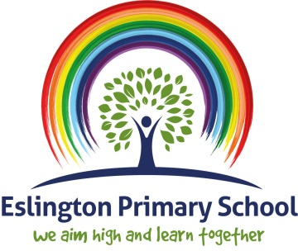

Relationships and Sex Education Policy

September 2023

1. Introduction
The ethos of Eslington Primary School is to enable every pupil aged 3 - 11 years with Social, Emotional and Mental Health difficulties (SEMH) to experience an enjoyable, happy and caring learning environment. It is intended that each pupil develops their full potential irrespective of their needs, ability, disability, race or gender.
Eslington Primary School is a maintained primary school for pupils from the ages of 3 to 11 years. It caters for pupils with Social, Emotional and Mental Health (SEMH) needs. In addition, pupils might have other needs such as Autistic Spectrum Condition (ASC), Dyslexia, Attachment Difficulties, Attention Deficit Hyperactivity Disorder (ADHD), Speech and Language, Pathological Demand Avoidance (PDA) etc and these needs are met by the skilled staff within school. Pupils are placed in the schools by the Special Educational Needs and Disability Team at Gateshead Council. We have a duty to promote children and young people’s wellbeing. Wellbeing is defined in the Children Act 2004 as the promotion of physical and mental health; emotional wellbeing; social and economic wellbeing; education, training and recreation; recognition of the contribution made by children to society and protection from harm and neglect. We also have a duty to promote community cohesion (Education and Inspections Act 2006; Education Act 2002).
This policy builds upon the mission statement:
‘We aim high and learn together’
This policy also recognises our Rights Respecting Ethos.

Rights Respecting Ethos
The United Nations Convention on the Rights of the Child (CRC) is at the heart of our school’s planning, policies, practice and ethos. As a Rights-Respecting school we teach an understanding of children’s rights and continually model mutual respect and promote an awareness of pupils’ rights. Everyone within the school community has rights, upon which we base our aims and school ethos. These have been further informed by the United Nations Convention on the Rights of the Child (UNCRC).
These rights are:
- To be safe
- To be heard
- To have beliefs
- To receive support
- To be treated with respect and dignity
- To learn/teach.

2. Aim of this policy
This policy has been formulated by the Senior Leadership Team and PSHE co-ordinator after consultation with the Local Authority’s Sex and Relationship Team and following the guidelines as set out in the DfE document 0116/2000. This policy reflects the needs and opinions of pupils, parents and stakeholders and reflects that pupils can join the school at any time during the academic year.

3. What is Relationship and Sex Education about?
Relationships and Sex education (RSE) provides an important contribution to the teaching of the spiritual, moral, cultural, emotional and physical development of pupils and in preparing them for the opportunities, responsibilities and experiences of adult life. Effective RSE is vital to ensure that pupils grow up able to enjoy the positive benefits of loving, rewarding and responsible relationships. Relationship and Sex Education is all about learning the emotional, social and physical aspects of growing up, relationships, sex, human sexuality and sexual health. Some aspects are taught in science, and others are taught as part of PSHE. A comprehensive programme of RSE provides accurate information about the body, reproduction, sex, and sexual health. It also gives children and young people essential skills for building positive, enjoyable, respectful and non-exploitative relationships and staying safe both on and offline. RSE involves a combination of sharing information and exploring issues and values and is not about the promotion of sexual activity.

4. Statutory guidance
We do not have to follow the National Curriculum but we are expected to offer all pupils a curriculum that is similar to the National Curriculum including requirements to teach science which would include the elements of sex education contained in the science curriculum.
In teaching RSE, we are required by our funding agreements to have regard to guidance issued by the Secretary of State for Education as outlined in section 403 of the Education Act 1996. This states that Eslington Primary School has a statutory duty which all schools are required to meet: ‘Every state-funded school must offer a curriculum which is balanced and broadly-based and which:

· promotes the spiritual, moral, cultural, mental and physical development of pupils at the school and of society.
· prepares pupils at the school for the opportunities, responsibilities and experiences of later life.

The Education Act 1996, as amended by the Learning and Skills Act 2000, requires headteachers and governing bodies to have regard to national guidance on Sex and Relationships Education in schools and to protect children from unsuitable teaching and materials. Under the Children Act 2004, schools have a duty to promote the well-being of their pupils and good quality RSE contributes to this duty.
Further, we recognise that as a school we have a responsibility under The Relationships Education, Relationship & Sex Education and Health Education (England) Regulations 2019, made under sections 34 & 35 of the Children & Social Work Act 2017, to provide comprehensive Relationship Education and Health Education for all pupils receiving primary education. The law requires that Relationships and Sex Education (RSE) is to be taught in all secondary schools in England, and that Relationships Education is to be taught in all primary schools in England. Health Education will also be mandatory in all Government-funded schools, which includes content on puberty.
Relationships Education in Primary schools is statutory. This consists of 32 outcomes (DFE guidance pages 20-21, see Appendix 2) that pupils should know ‘by the end of primary school’. The outcomes are not broken down into what should be taught when, so schools need to decide how to build these into a spiral, age-appropriate scheme of work.
Health Education in Primary schools is statutory. This consists of 35 outcomes (DfE guidance pages 32-35, further detail may be found within our separate PSHE policy) that pupils should know ‘by the end of primary school’. This includes outcomes relating to understanding puberty, and as such, parents are unable to opt out of their child receiving puberty education.
Sex Education at Primary level is NOT statutory within RSE or Health Education, though Primary schools are still required to teach the elements of sex education contained in the science curriculum. “Sex Education is not compulsory in primary schools” although, “the Department continues to recommend…that all primary schools should have a sex education programme tailored to the age and the physical and emotional maturity of the pupils” (DFE page 23).
Where a maintained primary school chooses to teach aspects of sex education (which go beyond the national curriculum for science), the school must set this out in their policy and all schools should consult with parents on what is to be covered. All schools are legally obliged to have an up-to-date RSE Policy that describes the content and organisation of RSE taught outside the science curriculum.
A comprehensive RSE programme can have a positive impact on pupils’ health and wellbeing and their ability to achieve and can play a crucial part in meeting these obligations. The Department of Health set out its ambition for all children and young people to receive high quality sex and relationships education in the Sexual Health Improvement Framework (2013).
The Marriage and Civil Partnership (Minimum Age) Act 2022 came into force in February 2023. Under previous law, people could enter a marriage or civil partnership at age 18, or 16 to 17 with parental or judicial consent. The Act raises the minimum marriage and civil partnership age to 18, removing all consent requirements. The Act extends existing forced marriage legislation, so it will be an offence to carry out any conduct causing a child to marry before their eighteenth birthday, even if violence, threats or another form of coercion aren’t used.
Marriage and forced marriage are taught as part RSE.

5. What are the aims and objectives of our RSE curriculum?
Our curriculum aims and objectives are:
- To support pupils to be wise and BE SAFE. This means having the confidence to say NO to experiences that they do not want to engage in.
- To provide a framework in which sensitive dicussions can take place.
- To teach pupils the correct vocabulary to describe themselves and their bodies.
- To support and enhance the personal, social and emotional development of all pupils.
- To promote self-esteem, confidence and acknowledge the value of oneself and others.
- To challenge any potential bullying behaviour and views.
- To enable pupils to make secure, informed, personal and safe choices.
- To help pupils to develop skills of communication within relationships.
- To develop a positive self-image and confidence and ensure that pupils know they are responsible for and in charge of their own bodies.
- To prepare pupils for puberty; to provide knowledge about the developing body, the portance of health and hygiene, the process of reproduction and the nature of sexuality.
- To provide the opportunity to discuss feelings, perceptions, values and experiences.
- To be sensitive to the needs of our pupils in recognising their cultural backgrounds and experiences and that of the society they live in.
- To promote a positive and healthy attitude to sex by challenging stereotyping based on gender or sexuality.
- To appreciate the value of stable family life, commitment to a partner and the responsibilities of parenthood.
- To increase awareness of sources of information, help and support.
- Highlight vulnerability and risks to young people particularly regarding the potential for their exploitation.
- To respect pupils’ right to confidentiality and work with parents to support their understanding of this.

6. How is RSE provided?
Pupils need to be given accurate information and support to develop skills to enable them to understand difference and respect themselves and others. A planned progressive programme of RSE will gradually and appropriately begin to prepare pupils for adult life. It will support the teaching of skills that pupils require, to manage effectively the natural physical and emotional changes that they experience as they grow and mature into healthy, confident and independent adults.
In line with national recommendations, RSE will be delivered through the PSHE, RE and science frameworks, reinforced throughout the whole of the school day and gradually developed through the age range. It will be delivered by the class teacher and on occasion, there will be input from external professionals who will work closely with the class team. Usually, pupils will work in mixed gender groups: however, there may be occasions when single gender groups are more appropriate and relevant.
Relationships education focuses on teaching the fundamental building blocks and characteristics of positive relationships including:
- Families and people who care for me
- Caring friendships
- Respectful relationships
- Online relationships
- Being safe

These areas of learning are taught within the context of family life; taking care to ensure that there is no stigmatisation of children based on their home circumstances. Families can include single parent families, LGBT parents, families headed by grandparents, adoptive parents, foster parents/carers as well as other permutations. We need to approach these contexts sensitively as some children may have a different support framework around them, for example: looked after children or young carers.
In addition to topics detailed within Eslington Primary school’s curriculum, staff may deliver lessons, provide safe spaces for group chats in class or lead whole school assemblies in response to issues that may be pertinent to children at that time, or that have been raised as topics of interest.
Pupils will also receive stand-alone health education sessions focussing on the changes in puberty delivered by a trained health professional.

7. How do we cover specific and sensitive issues related to RSE?
A range of sensitive issues may inevitably be raised by pupils, if not by the teacher. Such issues will be addressed with sensitivity, at a level appropriate to the age and ability of the pupils, and in an objective manner free from personal bias. Account will be taken of different viewpoints and beliefs. Discussions will be set within the legal framework and pupils supported to understand the law as it relates to specific issues.

- Confidentiality: – teachers will respect confidentiality with the exception that where a course of action may place a pupil at moral or physical risk, the teacher has a responsibility to inform the Head of School or a member of the Senior Leadership Team. Pupils are made aware and reminded that teachers cannot promise total confidentiality. Pupils will be offered sensitive and appropriate support and absolutely encouraged to discuss what they have learned and further questions they may have, with their parents/carers.

- Child Protection procedures: – where a pupil discloses sexual abuse or where a teacher has reason to suspect abuse, immediate action will be taken to inform the school’s Designated Safeguarding Lead (DSL) and the school’s Child Protection policy and procedure will be followed.

- Advice to pupils: – where an individual pupil asks specific advice on aspects of sexual behaviour, they will be encouraged to seek advice from their parents. Pupils will also be given contact information of agencies where more support and advice can be obtained. Some services, NHS provisions etc have authority to speak to pupils based on health protocols and as such, operate a confidential service direct with pupils.

- Prevention of Sexual Violence and Harrassment: - schools play an important role in preventative education. Keeping Children Safe in Education sets out that all schools should ensure children are taught about safeguarding, including how to stay safe online. Addressing inappropriate behaviour can be an important intervention that helps prevent problematic, abusive and/or violent behaviour in the future. Children displaying harmful sexual behaviour have often experienced their own abuse and trauma. It is important that they are offered appropriate support. Eslington Primary School has a clear set of values and standards, and these will be upheld and demonstrated throughout all aspects of school life. These are underpinned in the school’s behaviour policy and pastoral support system, and by a planned programme of evidence-based content delivered through the whole curriculum. Eslington Primary School is a rights respecting school and follows the four R’s. These are explained below:

The Four R’s
- Respect for ourselves, each other, cultures, religions, the environment and the world in which we live.
- Responsibility- being responsible citizens for the future.
- Resilience – knowing that it is OK to fail. To have the ability to bounce back and try again.
- Relationships - to understand what a healthy relationship is and be able to inform productive, healthy relationships to support us through school and our future.
As part of a whole school approach for prevention, it is important to recognise that sexual harassment can have both short and long-term consequences for victims and survivors which will appear differently for everyone, impacting mental health and wellbeing. Our RSE curriculum is delivered for stage not age and several factors are covered to make sure that sensitive issues are tackled. These include recognising and maintaining healthy and respectful relationships, behaving in respectful ways, recognising and resisting pressure, seeking help, consent, managing risk, understanding acceptable touch, sexual harassment and sexual violence.

Furthermore, the RSE curriculum complements the school computing curriculum, teaching age restrictions on online platforms and educating the children on how to be safe online, how to manage social media apps and web platforms, online privacy (data protection) including how to use privacy settings on their most- used platforms (e.g. Instagram, Snapchat, Tiktok), and knowing how to identify fake profiles. It is emphasised to the children attending Eslington Primary School that all these platforms have an age restriction over 11 years.
8. How do we support you as parents/carers?
The school recognises that there may be parental anxiety surrounding the teaching of RSE. To alleviate this, the school aims to:
- Recognise that parents are key people in terms of teaching their children about sex, relationships and growing up. The school aims to work in partnership with parents/carers and pupils: consulting them about the context of programmes of study.
- Recognise that parents have the right to withdraw their children from all or parts of the RSE programme outside of the National Curriculum. If parents wish their child to be withdrawn from the lessons, alternative educational provision will be made. Parents will be informed of the contents of the programme prior to its starting, either by phone, personal contact or letter and they will be invited to discuss any issues they may have with the PSHE Co-ordinator and Head of School/Assistant Headteacher.
- Recognise that the wider community has much to offer, and the school aims to work in partnership with health professionals, social workers and other appropriate personnel. Parents will be informed in advance of any outside bodies being used to deliver any parts of the curriculum.
- Consult with the parents of new entrants with regards to RSE as part of the admissions procedure.
- Provide a copy of the RSE policy on request, which is also available on the school website.
- Notify parents when Sex Education lessons are due to commence identifying the objectives, the activities being taught and resources to be used.

9. Organisation of our school’s RSE curriculum and teaching
- Staff training will involve a team-teaching approach where appropriate and information can be cascaded to other members of staff accordingly.
- A whole school approach will be applied with individual lessons on sex and relationships being taught within the PSHE programme using health promotions materials and specialist sexual health professionals.
- The programme will be planned and co-ordinated with the expectation that there will be space for discussion and that there is provision for pupils to work in small groups/with outside educators. Materials prepared by the teacher will be provided to all.
- Provision will be made for single sex teaching and individual follow up sessions as appropriate.
- Teaching staff will not be obliged to answer personal/controversial questions.
- The use of appropriate language will be always emphasised although ‘street language’ will be explored.
- Review: – the programme is evaluated by both staff and pupils using pro-forma covering attitudinal shift and knowledge on the subject.
- Resources will be appropriate according to the pupils’ interest, age and maturity.

10. What is the RSE curriculum at Eslington Primary School?
Our curriculum is set out as per Appendix 1, but we may need to adapt it as and when necessary.
We have developed the curriculum in consultation with parents, pupils and staff, considering the age, needs and feelings of pupils. If pupils ask questions outside the scope of this policy, teachers will respond in an appropriate manner, so they are fully informed and do not seek answers online.
Every year group will access some RSE within their curriculum. This can either be through subject taught lessons or through whole school assemblies, activities during the PSHE curriculum, off-site visitors or trips and by workshops led by external visitors.

Statutory Relationships education focuses on teaching the fundamental building blocks and characteristics of positive relationships including:
- Families and people who care for me
- Caring friendships
- Respectful relationships
- Online relationships
- Being safe

These areas of learning are taught within the context of family life, taking care to ensure that there is no stigmatisation of children based on their home circumstances. As outlined above, families can include single parents, LGBT parents, families headed by grandparents, adoptive parents, foster parents/carers etc and we need to be sensitive to the fact that some children may have a different support framework around them (for example: looked after children or young carers).

- Morals and values: the moral and values framework, which informs the teaching of sex education is reflected in the school’s aims and the ethos as defined in the SMSC Policy.

- Equal opportunities: all are treated equally. No one is excluded from having the opportunity to take part in the sex education programme. Parents can withdraw their children from sex education lessons by advising the school in writing. Access to information and support agencies is available to all pupils. Targeted single sex sexual health education is also offered now that girls attend the school. This allows an opportunity to equal access to information.

Non-statutory sex education RSE lessons at Eslington Primary school will discuss human reproduction within a social context, to support the statutory teaching of the biology of human reproduction that forms part of the Science curriculum. This will involve helping children to understand the place of sexual intercourse within a consensual relationship and how this leads to the wonder of new life, as well as allowing children to ask any questions they may have and addressing any misconceptions. Parents will be informed by staff before this content is taught in school, with the option of opting out of this if they wish. The withdrawal from is included below in Appendix 3.

11. RSE policy overview and roles and responsibilities
The PSHE Co-ordinator and the Senior Leadership Team are responsible for monitoring the standards of pupils’ work and the quality of teaching. They are expected to support colleagues in the teaching of RSE by giving them information about current developments in the subject. Strengths and weaknesses in the subject and areas for further improvement are discussed with the Head of School and colleagues, and feedback is given to the governor responsible for PSHE and Citizenship.

The governing board
The governing body will approve the RSE policy and hold the Head of School to account for its implementation.

The Head of School
The Head of School is responsible for ensuring that RSE is taught consistently across the school, and for managing requests to withdraw pupils from [non-statutory/non-science] components of RSE.

Staff
Staff are responsible for:
- Delivering RSE in a sensitive way
- Modelling positive attitudes to RSE
- Monitoring progress
- Responding to the needs of individual pupils
- Responding appropriately to pupils whose parents wish them to be withdrawn from the [non-statutory/non-science] components of RSE.
Staff do not have the right to opt out of teaching RSE. Staff who have concerns about teaching RSE are encouraged to discuss this with the Head of School.

Pupils
- Pupils are expected to engage fully in RSE and, when discussing issues related to RSE, treat others with respect and sensitivity.

Parents’ right to withdraw
- Parents do not have the right to withdraw their children from relationships education.
- Parents have the right to withdraw their children from the [non-statutory/non-science] components of sex education within RSE.
- Requests for withdrawal should be put in writing using the form found in Appendix 1 of this policy and addressed to the Head of School.
- Alternative work will be given to pupils who are withdrawn from sex education.

Staff training/CPD
- The school is committed to improvements in the delivery of good quality RSE teaching and sees current and future training as important for those who deliver curriculum.
- Staff are responsible for liaising with the Head of School or a member of the Senior Leadership Team to identify areas in which they feel that they would require training: - a range of service providers are accessible to the school
- The PSHE Co-ordinator, in conjunction with the Head of School provides INSET training for the whole school.

Resource Provision
- The PSHE Co-ordinator is responsible for the purchasing of RSE resources
- Class teachers are required to also provide resources to help with cross curricular activities within their lessons that are linked to RSE.

Dissemination of the RSE Policy
- All members of staff will be given a full copy of the RSE policy
- All governors will receive a copy of the RSE policy
- Policies are available on the website to any other interested parents (e.g. parents, visitors, LA officers).

12. Monitoring and evaluating the RSE Policy
To monitor and evaluate the effectiveness of the policy and its implementation, the following steps will be taken:
- Pupil feedback
- Staff consultation
- Parent/stakeholder consultation
- Changes made to the school ethos in relationship to whole school PSHE curriculum.
- Changes to the science curriculum.
Yearly reviews will be made to recognise changes that may occur. This policy is reviewed annually.

- Feedback from Parent Consultations
In July 2021, parents and carers of children attending Eslington Primary School were given the opportunity to participate in a consultation on the school’s teaching of Relationships and Sex Education. They were invited to complete an online questionnaire and give feedback about the current policy and curriculum aims.
The questionnaire responses showed that parents and carers are mostly aware of our current RSE policy, feel adequately informed about the RSE curriculum and that our current RSE curriculum meets the needs of their children.
When given the opportunity to tell us what we could do better around the teaching of the RSE curriculum we received comments detailed below:

You said… | We did…
“Will there be any teaching about positive self-esteem and mental health?” | As part of a relaunch of our school’s creative curriculum offer, our PSHE and RSE curriculum has been reviewed and extra topics added for September 2021. Objectives linked to self-esteem and mental health feature in the curriculum in every year group within the ‘Feelings and Emotions’ and ‘Growing and Changing’ themes.
“I think it’s very important to understand stereotypes and that relationships come in all sizes and with different types of people.” | Understanding, respecting and valuing differences in people and relationships is a key theme throughout the PSHE and RSE curriculum. Stereotypes are specifically referred to in the Year 6 ‘Valuing Difference’ topic.
“I’d like to know how to find out more about what will be taught in school.” | This policy will be available on the school website, with the school’s curriculum included below, in Appendix 2.

- Feedback from Staff Consultations
As part of the consultation period, staff were also invited to complete an online survey, with opportunities to express how they felt about teaching the RSE curriculum and to identify any extra support they felt was required.
Staff comments that require action are detailed and categorised below:

Issue | You said… | We did…
Healthy Relationships | “Healthy positive relationships different types of relationships/families should be addressed in the curriculum.”  “I think that there are more social media platforms that talk openly about sex and relationships now and more of our children are accessing these sites at a younger age. They may read or hear things but do not always understand them.”  “Healthy relationships and differences in anatomy (male/female) could be addressed earlier.”  “Gender and sexuality could be broached earlier also, so that our pupils are informed and not ignorant of others.” | - Healthy Relationships is a core theme in our RSE curriculum, and this is clearly indicated in our curriculum framework.  - Our RSE curriculum also covers online safety and how to identify and report harmful content.  - RSE is taught from Year 1. From September 2021, our curriculum features a specific objective in Year 1 that introduces children to the correct names for body parts and bodily similarities and differences between boys and girls.  - The RSE curriculum, informed by DfE guidance, now clearly outlines teaching of the diversity of families, relationships and all other protected characteristics.
Sexual Harassment | “Maybe some of the newer agendas such as up skirting, sexual harassments in school could be highlighted as they are in the news recently. I do think these issues are covered in school and addressed in class.” | Eslington has now developed a sexual harassment policy. How this relates to the teaching of RSE is outlined in this policy in Section 7 (v). PSHE/ RSE topics that are beyond what is outlined in the curriculum and are raised by children or need to be addressed immediately will be taught as part of the child-led and responsive element of PSHE in school.
Mental Health | “More about mental health than is in the PHSE association resources.” | The RSE curriculum covers many aspects of mental health and wellbeing, including managing feelings, asking for help, building positive relationships, being part of a community, recognising personal strengths and awareness of bullying and how to report it.
Staff awareness of statutory requirement | “I do not know where to find our school’s RSE policy.”  “I do not fully understand the changes to the RSE curriculum." | This RSE policy has now been shared with staff via CPOMS. Staff to confirm via this system when they have read the policy. Staff will have further opportunities to ask questions during whole staff training in Spring 2022.
Delivery of the curriculum | “I think PSHE and RSE should be taught every day.”  “I think we should have more cross curricular links to the RSE curriculum.”  “I’d like to know what age groups should know or be taught about what and when.” | The senior leadership team have reviewed the daily timetable and have ensured that time has been allocated every afternoon for the delivery of PSHE and RSE lessons.  In September 2021, a new topic curriculum was implemented across school that encourages the use of cross curricular links across all subjects. Each half term’s theme is inspired by curriculum drivers that focus on key elements of respect, relationships, teamwork, resilience and empathy.  A progression of skills document has also been produced to help teachers identify what they are required to teach and how to build on previous learning.
Teaching Resources | “I highly rate the PSHE Association website for resources.”  “Some of the resources that are on Twinkl that would be beneficial for supporting these lessons aren't included in our subscription.” | School membership of the PSHE Association website has been renewed.  School membership of Twinkl and of the Sex Education forum is currently under review.
Professional Development | “Staff need more support with delivery of the curriculum.”  “I’d like training about how to teach the topics.” | Training for all staff that included the content and rationale behind our RSE curriculum was delivered in March 2022.

A further consultation with parents and staff is scheduled for Spring 2024.

Appendix 1: Eslington Primary School PSHE & RSE Curriculum Progression of Skills (topics in italics indicate RSE objectives)
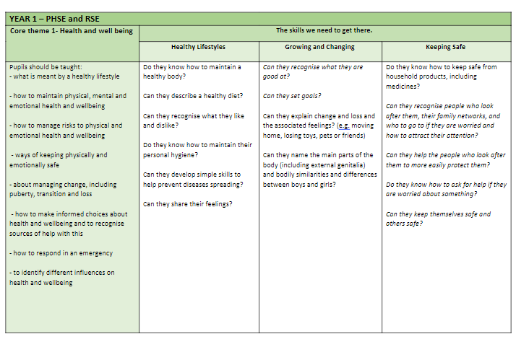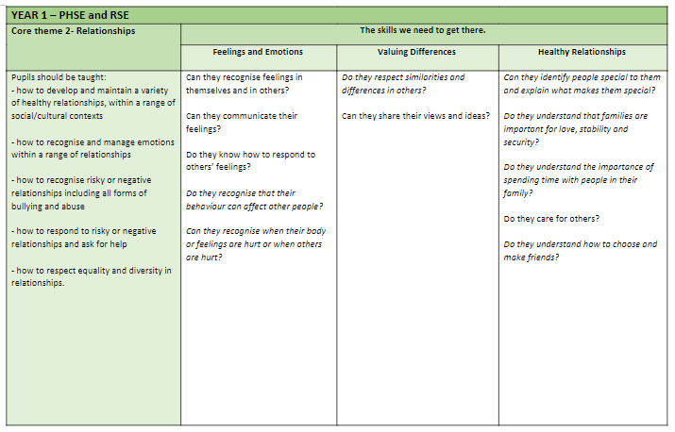
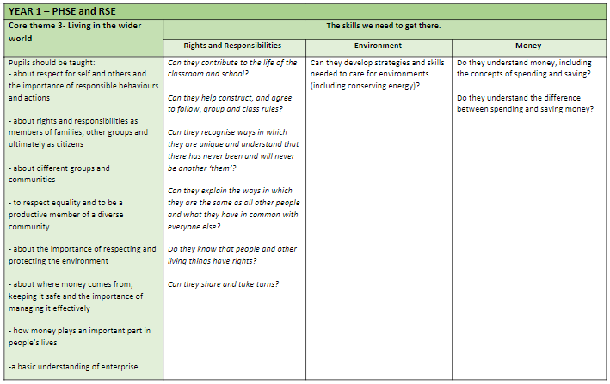
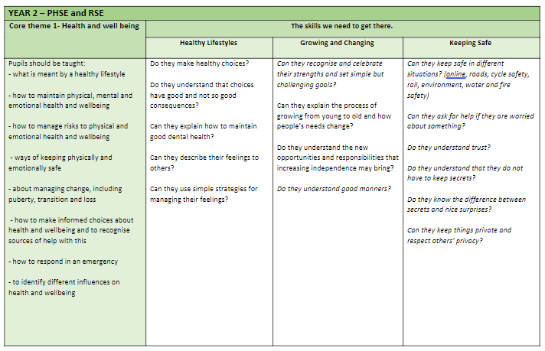
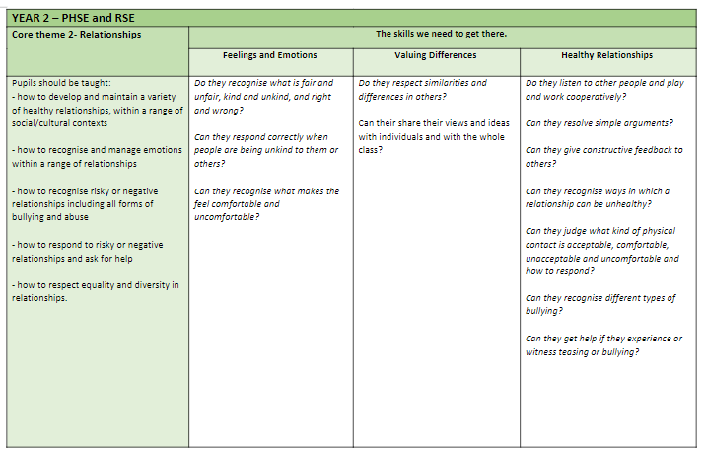
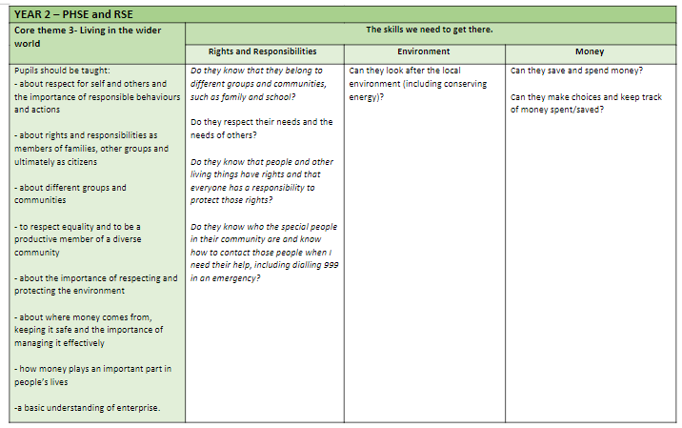
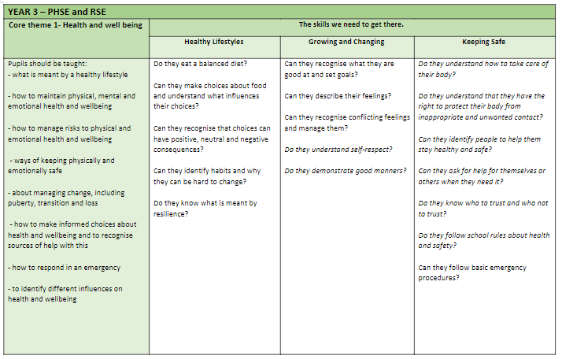
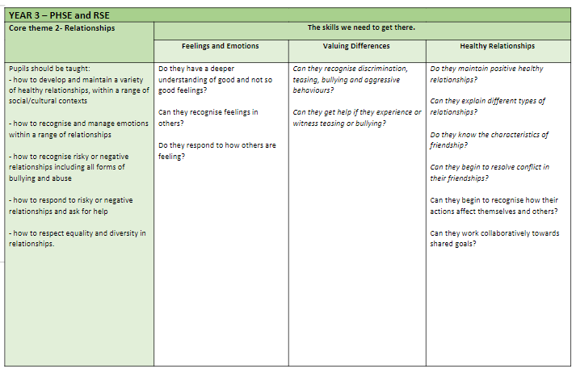
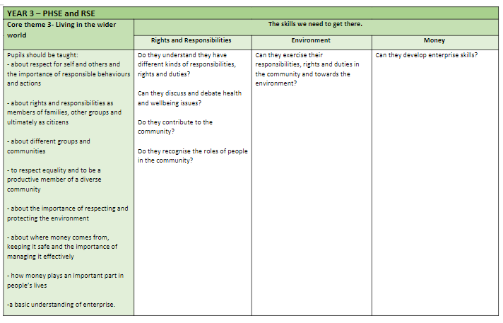
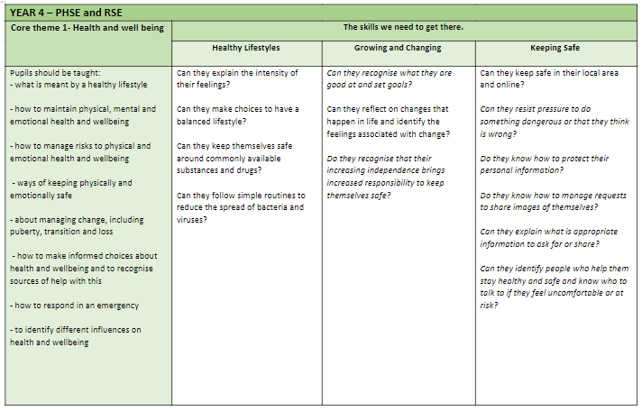
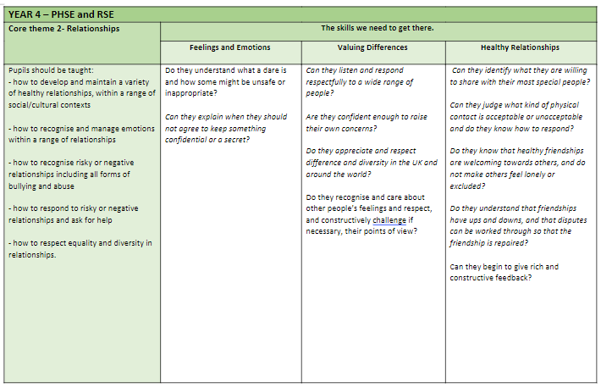
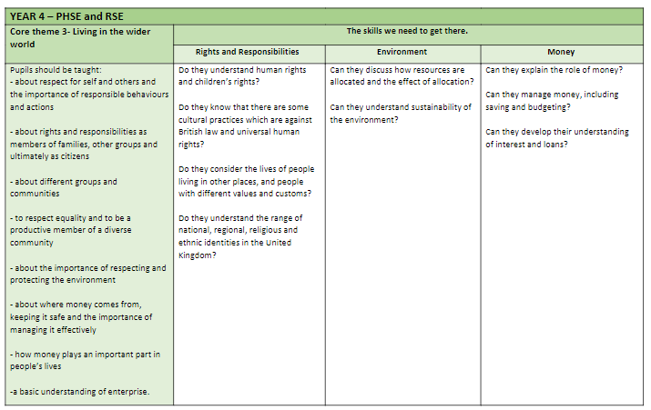
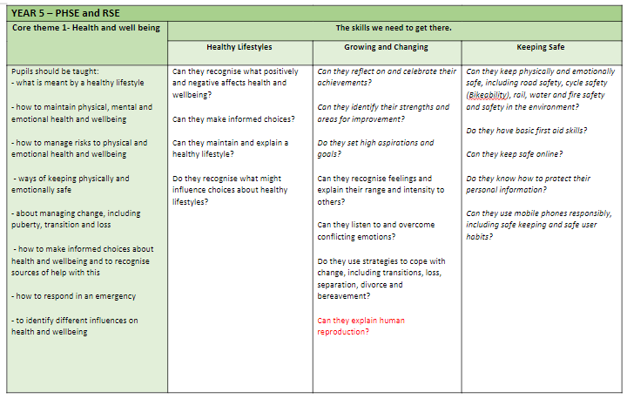
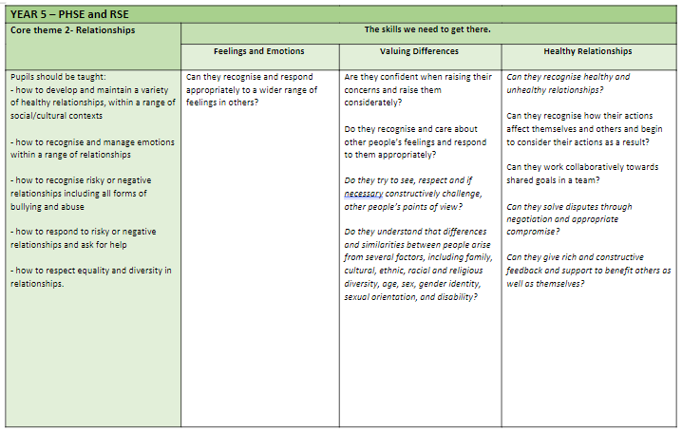
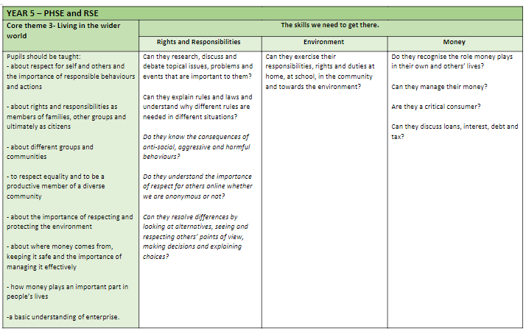
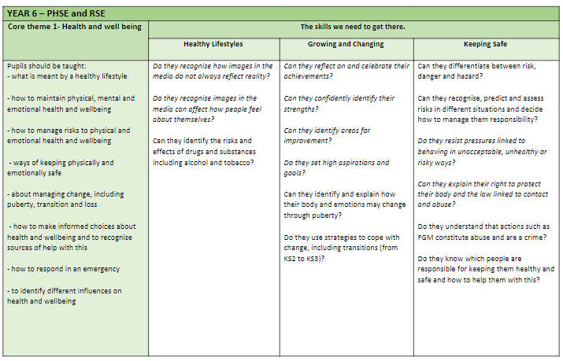
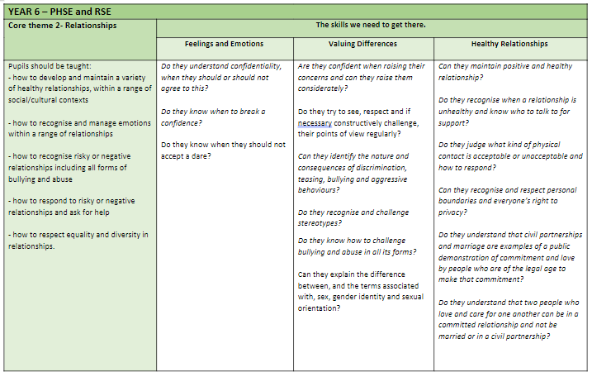
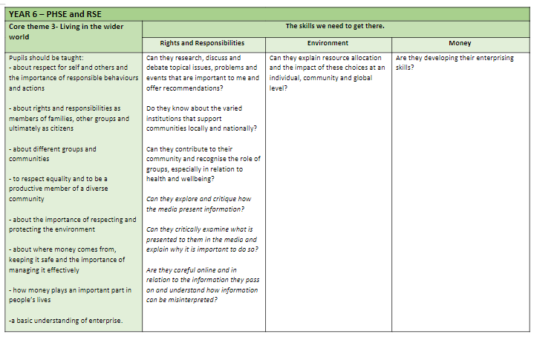

Appendix 2: DfE statutory RSE targets by end of KS2
Topic | Pupils Should Know
Families and people who care about me | - That families are important for children growing up because they can give love, security and stability Y1 Keeping Safe, Y1 Healthy Relationships, Y2 R & R  - The characteristics of healthy family life, commitment to each other - including in times of difficulty, protection and care for children and other family members, the importance of spending time together and sharing each other’s lives Y5 Healthy Relationships  - That others’ families, either in school or in the wider world, sometimes look different from their family, but that they should respect those differences and know that other children’s families are also characterised by love and care Y1 Valuing Difference, Y2 Valuing Difference, Year 5 Valuing Difference  - That stable, caring relationships, which may be of diverse types, are at the heart of happy families, and are important for children’s security as they grow up Y1 Healthy Relationships, Y3 Healthy Relationships, Year 5 Healthy Relationships  - That marriage represents a formal and legally recognised commitment of two people to each other which is intended to be lifelong Y6 Healthy Relationships  - How to recognise if family relationships are making them feel unhappy or unsafe, and how to seek help or advice from others if needed. Y3 Healthy Relationships, Y4 Healthy Relationships, Y5 Healthy Relationships
Caring friendships | - How important friendships are in making us feel happy and secure, and how people choose and make friends Y1 Growing and Changing, Y1 Healthy Relationship, Y3 Healthy Relationships,  - The characteristics of friendships, including mutual respect, truthfulness, trustworthiness, loyalty, kindness, generosity, trust, sharing interests and experiences and support with problems and difficulties Y3 Healthy Relationships  - That healthy friendships are positive and welcoming towards others, and do not make others feel lonely or excluded Y3 Healthy Relationships, Y4 Healthy Relationships  - That most friendships have ups and downs, and that these can often be worked through so that the friendship is repaired or even strengthened, and that resorting to violence is never right Y4 Healthy Relationships, Y5 Healthy Relationships  - How to recognise who to trust and who not to trust, how to judge when a friendship is making them feel unhappy or uncomfortable, managing conflict, how to manage these situations and how to seek help or advice from others, if needed. Y2 Keeping Safe, Y2 Feelings and Emotions, Y2 Healthy Relationships, Y3 Keeping Safe, Y3 Healthy Relationships, Y4 Healthy Relationships, Y5 Healthy Relationships, Y5 R&R, Y6 Healthy Relationships
Respectful relationships | - The importance of respecting others, even when they are vastly different from them (for example, physically, in character, personality or backgrounds), or make different choices or have different preferences or beliefs Y4 Valuing Difference, Y5 Valuing Difference, Y6 Valuing Difference  - Practical steps they can take in a range of different contexts to improve or support respectful relationships Across the all year groups and themes  - The conventions of courtesy and manners Y2 Growing & Changing  - The importance of self-respect and how this links to their own happiness Y1 Growing & Changing, Y2 Healthy Lifestyles, Y2 Growing & Changing, Y3 Growing & Changing  - That in school and in wider society they can expect to be treated with respect by others, and that in turn they should show due respect to others, including those in positions of authority Y1 R&R, Y2 R&R, Y5 Environment  - About different types of bullying (including cyberbullying), the impact of bullying, responsibilities of bystanders (primarily reporting bullying to an adult) and how to get help Y2 Healthy Relationships, Y3 Valuing Difference, Y6 Valuing Difference  - What a stereotype is, and how stereotypes can be unfair, negative or destructive Y6 Valuing Difference  - The importance of permission-seeking and giving in relationships with friends, peers and adults. Y2 Keeping Safe, Y2 Healthy Relationships, Y2 Feelings & Emotions, Y4 Keeping Safe, Y4 Healthy Relationships, Y4 Feelings and Emotions, Y6 Keeping Safe, Y6 Healthy Relationships
Online relationships | - That people sometimes behave differently online, including by pretending to be someone they are not Y2 Keeping Safe, Y4 Keeping Safe, Y5 Keeping Safe  - That the same principles apply to online relationships as to face-to face relationships, including the importance of respect for others online irrespective of whether we are anonymous or not Y5 R&R, Y6 R&R  - The rules and principles for keeping safe online, how to recognise risks, harmful content and contact, and how to report them Y2 Keeping Safe, Y4 Keeping Safe, Y5 Keeping Safe  - How to critically consider their online friendships and sources of information including awareness of the risks associated with people they have never met Y2 Keeping Safe, Y4 Keeping Safe, Y5 Keeping Safe  - How information and data is shared and used online. Y2 Keeping Safe, Y4 Keeping Safe, Y5 Keeping Safe, Y6 R&R
Being safe | - What sorts of boundaries are appropriate in friendships with peers and others (including in a digital context) Y4 Keeping Safe, Yr 6 Healthy Relationships, Y6 R&R  - About the concept of privacy and the implications of it for both children and adults; including that it is not always right to keep secrets if they relate to being safe Y2 Keeping Safe, Y4 Feelings & Emotions, Y6 Healthy Relationships  - That each person’s body belongs to them, and the differences between appropriate and inappropriate or unsafe physical, and other, contact Y2 Healthy Relationships, Y3 Keeping Safe, Y4 Healthy Relationships, Y6 Keeping Safe, Y6 Healthy Relationships  - How to respond safely and appropriately to adults they may encounter (in all contexts, including online) whom they do not know Y4 Valuing Difference  - How to recognise and report feelings of being unsafe or feeling bad about any adult Y1 Keeping Safe, Y2 Keeping Safe, Y3 Keeping Safe, Y4 Keeping Safe, Y6 Keeping Safe  - How to ask for advice or help for themselves or others, and to keep trying until they are heard Y1 Keeping Safe, Y2 Keeping Safe, Y2 Healthy Relationships, Y2 R&R, Y3 Keeping Safe, Y3 Valuing Difference, Y4 Keeping Safe, Y6 Keeping Safe  - How to report concerns or abuse, and the vocabulary and confidence needed to do so Y4 Valuing Difference, Y5 Valuing Difference, Y6 Feelings and Emotions, Y6 Valuing Difference  - Where to get advice e.g. family, school and/or other sources. Y1 Keeping Safe, Y2 Keeping Safe, Y2 Healthy Relationships, Y2 R&R, Y3 Keeping Safe, Y3 Valuing Difference, Y4 Keeping Safe, Y6 Keeping Safe

Appendix 3: Parent form: withdrawal from sex education within RSE

To be completed by parents
Name of child |  | Class
Name of parent |  | Date
Reason for withdrawing from sex education within Relationships and Sex Education
Any other information you would like the school to consider
Parent signature

To be completed by the school
Agreed actions from discussion with parents

