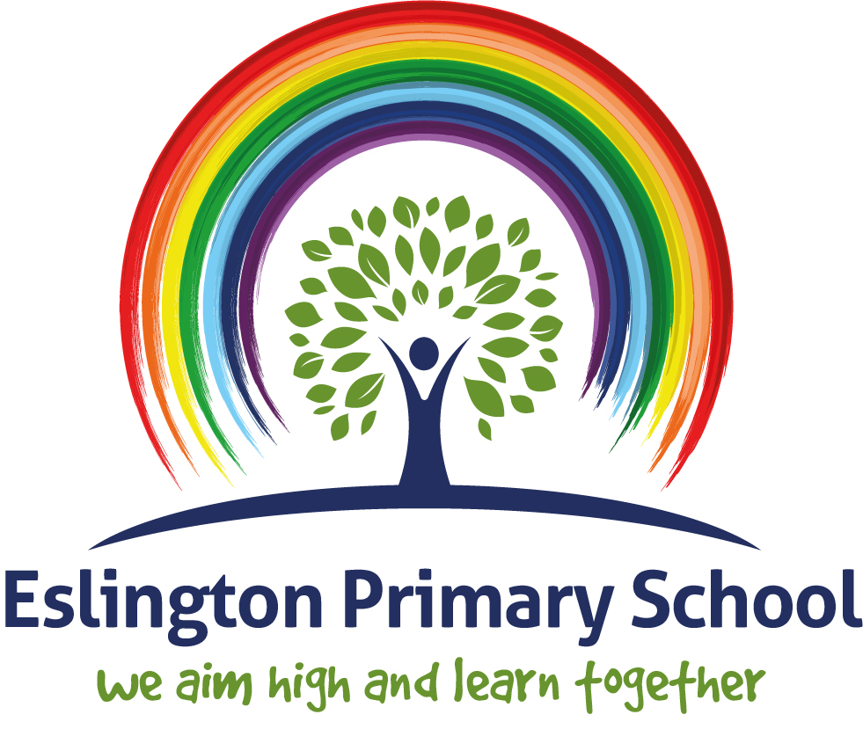

Spiritual, Moral, Social and Cultural (SMSC)
Development within our Curriculum

 | We promote spiritual  development by… | We promote moral  development by… | We promote social  development by… | We promote cultural  development by…
English | Connecting our own lives to the characters in the text. | Discussion of moral dilemmas in a variety of genre texts. | Exploring social attitudes towards language. | Looking at stories, poems and non-fiction texts from around the world.
 | English engages children with poetry, fiction and drama. | Linking these moral dilemmas  to their own life and how they choose what is right and wrong. | How has written and spoken language changed over time.  Working in teams for speaking and listening activities. | Using role play to explore the lives of characters from other cultures  including language and accent.
 | It invites and encourages the children to explore feelings and values in a wide range of genres. |  |  | Exploration of social class  through spoken language and roles of characters in books.
 | Encourages confidence and self-belief through drama, speaking and listening activities. |  | Working in groups to generate ideas.
 |  |  | Peer to peer editing and
idea sharing.

Using drama to perform in front of peers to deepen understanding of texts
Maths | Children are engaged in deeper thinking with regards to problem solving. | Maths encourages children to look at, discuss and evaluate a range of social and moral issues in the world. | A requirement for verbal reasoning.  Working in groups or teams to solve problems. | Maths exposes the children to range of approaches to solving problems and reasoning skills.
 |  | It can sometimes draw upon  other areas of study such as history and geography. | Sharing resources.
Children have the
opportunity to discuss their learning with their peers.

Science | Year 6 look at evolution Harvest Assembly.  Easter/Spring celebrations. Celebrating new life.  Creating awe and wonder across all age ranges through experiments and investigating.  Rasing aspirations of children through giving them awareness of science careers. | Children are encouraged to think about the impact of science on the world in many different ways:  Is it right to test drugs on animals?  Should we turn the animal’s  habitat into a skate park?  Can we develop an eco-friendly fuel/packaging?  Developing an understanding of gender stereotypes in STEM careers  How much energy do you use? | Developing skills for finding solutions working as a team.  Taking part in practical investigations (working scientifically) | Children are encouraged to look at future prospects and how scientific skills will help them in everyday lives and the wider world.  Taking part in British Science Week

Art | Expressing their feelings through media.  Exploring how art makes them feel and why.  Explore how art makes other feel, e.g. the artist and the audience.  Creating art in the style of other artists. | Debating what is and isn’t art. Why do the children think that?  Different artists perspectives why is art different to everyone.  Art is a form of speech how is this shown in artists work?  Using art to discuss real life moral dilemmas. | Children to discuss and share their personal opinions about art work.  Children work in groups or teams to create and collective piece of work.  Children generate ideas together.  Discuss what art might be trying to explain to use with regards to social issues now and in the past.  Children to be able to discuss feedback and share constructive comments within a polite manner. | Looking at and exploring art and artists from different countries and cultures.  Comparing what can be seen in art pieces from around the world and discuss the issues that would make them different.  Explore the materials used within art from around the world.
Computing | How can technology bring rapid benefits to discussions and tolerance of pupil’s beliefs?  Children are exposed to the limitations and the abuse of the internet where they question and justify aims, values and principles of their own and other’s belief systems.  ICT lets students have the opportunity to reflect on how computers can sometimes perform better in certain activities than people. | Looking at how developments of technology have had an impact on the environment as technology has meant that old ways of working have been changed to help the environment.  STEM career choices  Consider the effects of social networking and the consequences of cyber bullying; they also consider the legal aspects of ICT including the Data Protection Act, CopyWrite | Completing group work including practical activities with other children.  Collaborative problem solving skills involving programming skills such as Lego Education and VEX robotics  Code Clubs run during social times  Computing trips and visits such as Lego work shop and 3D printer  Work together with others to produce a project such as class/school videos  To explore and understand social media and the advantages that these sites can bring as well as the problems that can arise including cyber bullying.  Children can express themselves in areas that interest them | Exploring how technology has impacted some cultures and countries differently to others.  Studying how more developed countries have kept up with the pace of technology whereas less developed countries haven’t. Children to explore the factors effecting this.
Design Technology | Creative thinking and innovation encourages the children to discover new talents. | Moral dilemmas discussed with the creation of new products and new technology. | Health and safety of yourself and others with tools and instruments.  Encourage group and team | Industrial routes- what has already been made, other products currently on the market.

 | Builds self-confidence and belief in their own abilities.  The purpose of the product and how it may vary depending on the user.  Creative approaches to recognise the mechanics of products being made.  Encourages the use of creative instincts. | What is the impact on the environment with the new product that is being made?  Consider environmental issues and impact.  Fair testing – ethics and morals e.g. animal testing.  Incorporate feedback from product testing. | efforts; sharing ideas and compromising.  Peer evaluation on products made.  Children to be able to discuss feedback and share constructive comments within a polite manner.  Taking on feedback in order to improve the product. | What similar products are available in other countries- why are they different?  How does the product vary in each country? How does this affect the user?  Children to recognise a product can be accessible for all.

Geography | Promotes and sense of wonder and fascination with human and physical aspects of the world.  Creating an understanding of scale- how small changes in climate can have far reaching consequences.  Understand that all life in linked and creates the processes that make Earth the only habitable planet. | Exploring and discussing a range of Geographical moral dilemmas.  - How the development of cities has affected wild-life.  - How different countries tackle and ever increasing population.  - Poverty.  - Environmental issues surrounding importing goods from other countries. | Social issues are common themes within Geography.  It is important for the children to work together and out of school to help tackle the issues raised such as global warming. | How can different cultures and beliefs have an impact on the environment and human issues?  Children study different places around the world and are introduced to their culture and customs.  Children develop their humility and begin to understand that the world is a global community.
Music | Ability to be reflective about their own beliefs, religious or otherwise and use this to create and choose music.  Sense of enjoyment and fascination in learning about themselves, others and the world around them.  Use of imagination and creativity in their learning.  Willingness to reflect on their experiences.  Religious songs and collective worship during assemblies.  Celebrating religious festivals.  Performing religious stories e.g. The Christmas Nativity. | Ability to recognise the difference between right and wrong- lyrics and music and the theory behind the music or song.  Understanding of the consequences of their behaviour and actions.  Interest in investigating and offering reasoned views about moral and ethical issues in music and being able to understand and appreciate the viewpoints of others on these issues.  Reflections in music. | Use a range of social skills in different contexts, including working and socialising with pupils from different religious, ethnic and socioeconomic backgrounds.  Willingness to participate in a variety of communities and social settings, including by volunteering, cooperating well with others and being able to resolve conflicts effectively.  Develop social confidence with performances including singing and performing.  Working together to collaboratively perform music and ensembles.  Acceptance and engagement with the | Looking at and exploring music, songs, composers and artists from different countries and cultures.  Comparing what can be heard and interpreted from music and lyrics from around the world and discuss the issues that would make them different.  Access to different types of music, listening to and performing different genres and linking them to cultures.  Cultural performances.

 |  |  | fundamental British values of democracy, the rule of law, individual liberty and mutual respect and tolerance of those with different faiths and beliefs; the pupils develop and demonstrate skills and attitudes that will allow them to participate fully in and contribute positively to life in modern Britain.
History | Encourages a sense of curiosity and mystery of how and why events happened.  What would be different now if things had happened differently?  Pupils are encouraged to explore the role played by important individuals, for good or ill, in the shaping of the world we live in.  Pupils reflect on different interpretations of the past and how they have been arrived at. | Consider and comment on moral dilemmas and questions.  Is that happened in the past acceptable today? If not, why not?  Encouraged to show compassion for people facing dilemmas and empathise with their decisions.  Notations of right and wrong are explored around events that happened in the past. | Explore the similarities and differences between past and present societies.  Explore why we are fortunate to live in the modern world.  How did other cultures have an impact on what we know to Britain today?  Collaborative and team work in activities. | Encouraged to gain an understanding of and empathise with people from different cultural backgrounds.  Pupils develop a better understanding of our multicultural society through studying links between local, British, European and World history.

PE | Understand how to overcome challenges with determination and perseverance.  Explain how confidence can effect performance.  Identify ways of dealing with stress using physical activity.  Recommend suitable activities for healthy lifestyle for different ages.  Identify areas they are confident in.  Understand that being healthy incorporates body, mind and lifestyle.  Being gracious in success as well as defeat.  Sports day.  Make links between balanced lifestyle and being happy.  Understand a variety of tactics and strategies for different activities. | Understand the difference between fair/unfair.  Begin to set goals and identify if their targets have been met.  Offer suggestions on how to offset negative mood.  Offer solutions to problems. | Identify the importance of having friends and know what characteristics make a good friend.  Listen to advice on how to improve skills from peers and teachers.  Share own views and listen to and consider views/opinions of others. Work effectively with a partner/small group/team.  Participate in competitive activities.  Recognise own roles and responsibilities within a team.  Evaluate performances of self and others looking for areas of strength and weakness  Sporting competitions, mixing in the community. | Understanding the Olympics for different cultures and traditions.  Take part in traditional games/activities of different cultures.  Discuss the health of people from different countries/regions.  May pole/May day links to traditional cultures.

PSHE | Engage children with a range of mindfulness activities.  Children explore a range of feelings and values across a range of situations and scenarios through role play, story-telling and discussions.  ‘Feelings and Emotions’ topic covered in every year group. | Children are encouraged to look at, discuss and evaluate a range of moral issues based on different case studies and scenarios.  Children discuss what is right and wrong and connect this the British Value; Rule of Law.  Topics ‘Feelings and Emotions, Rights and Responsibilities and Valuing Difference’ covered in every year group which focus on individual responsibilities and moral issues. | Providing the children with an environment in which they can share their views and feel safe.  ‘Keeping Safe and Healthy Relationships’ topics covered in every year group which considers personal safety and responsibility of keeping others safe, as well as how to form and maintain positive relationships.  Children are encouraged to listen to and value the beliefs and opinions of others. | Children are exposed to wide range of experiences and situations and they can be explored from other people’s points of view.  Topics ‘Rights and Responsibilities and Valuing Difference’ covered in every year group which focus on individual differences, human rights, and the importance of respect.
RSE | Learning and understanding physical development at appropriate stages.  Understanding human sexuality, reproduction, emotions and relationships. | Learning the importance of values and individual conscience and moral considerations.  Learning the value of family life, marriage, and stable and loving relationships for the nurture of children.  Learning the value of respect, love and care.  Exploring, considering and understanding moral dilemmas.  Developing critical thinking as part of decision-making. | Learning to manage emotions and relationships confidently and sensitively.  Developing self- respect and empathy for others.  Learning to make choices based on an understanding of difference and with an absence of prejudice.  Developing an appreciation of the consequences of | Exploring, improving understanding of and showing respect for different faiths and cultural diversity- this may arise where pupils from other cultures may have opposing views to that of what is being taught.

choices made.

Managing conflict and learning how to recognise and avoid exploitation and abuse.
RE | Learning about different spiritual beliefs around the world.  Learning about spiritual practices around the world.  Felling confident to share our own spiritual beliefs.  Explore a range of religions and explore ways that people worship, celebrate events and show that they are part of a community.  Trips to places of worship  Daily Prayers and collective worship in assemblies. | Opportunities to reflect upon own self beliefs and beliefs of others.  Discussions of what is right and wrong to different people.  Reflection time, use of a stimulus to provoke thoughts on morality e.g. a book, poetry, artwork.  Discuss the morality of different stories and why they are an important part of different religions and cultures. | Discussion with others about worldviews.  Sharing religious values, beliefs and practices.  Learning from people in the local area.  Children can learn about the world around them. | Learning of different cultural beliefs, religions and practises.  Learning about practices and ways of life across the world.  Trying food from different cultures.  Visiting different places of worship.
Extra-curricular | A variety of religious topics covered in assemblies  Enrichment days and workshops that allow pupils to ask questions and further develop their understanding of feelings  Music with external agencies – J Parkin | Assemblies  Eco-Warriors  Waldo-Wordlies  Rights respecting  Bag to School and raising money for charities  School council | Assemblies  Enrichment days  After-school clubs  Music  Workshops | Trips  Enrichment days  Social time activities

