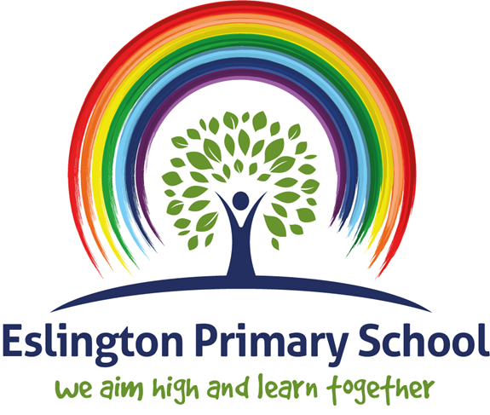

Science Policy

2023-24

National Curriculum Purpose of Study
A high-quality science education provides the foundations for understanding the world through the specific disciplines of biology, chemistry and physics. Science has changed our lives and is vital to the world’s future prosperity, and all pupils should be taught essential aspects of the knowledge, methods, processes and uses of science. Through building up a body of key foundational knowledge and concepts, pupils should be encouraged to recognise the power of rational explanation and develop a sense of excitement and curiosity about natural phenomena. They should be encouraged to understand how science can be used to explain what is occurring, predict how things will behave, and analyse causes.
National Curriculum 2014

Rational
At Eslington, we aim to build on pupils’ natural curiosity and understanding of the world to develop scientific knowledge, vocabulary and skills through practical investigations, individually and in groups. Pupils are encouraged to make links between what they observe in the world around them and scientific processes. We aim to develop their curiosity through enquiry and exploration understanding of the key scientific areas:

- Life processes and living things

- Materials and their properties

- Physical processes.

Our science curriculum supports our 4R’s and provides opportunities to also develop socially and emotionally. We encourage children to take responsibility for the learning to work scientifically to devise their own experiments and fair tests, to predict outcomes of investigations, and to evaluate and compare their findings, reflecting of their learning journey and building their resilience. There are also opportunities for critical thinking, questioning and reasoning. Skills acquired in other key areas of the curriculum – English, maths and ICT are regularly applied and practised within science lessons, through writing up, recording and presenting results.

Through our spotlight days we give pupils the opportunity to make cross curricular links providing them with more opportunity work scientifically and ask further questions.

Aims
The school should ensure that all children:
- Feel confident and successful in their Science learning
- Demonstrate the 4R’s
Relationships: working alongside their peers to plan and carry out investigations.
Resilience: Be challenged and understand that mistakes are part of the process of learning.
Respect: Keeping yourself and others safe when taking part in scientific investigations.
Responsibility: understand that science is relevant in understanding the world.
- Enjoy learning and experience the excitement of science.
- Have a voice and be able to choose how they wish to learn and think like a scientist– the resources and maths they feel are most appropriate.
- Understand that Science is relevant to everyday living and a lifelong skill, by solving problems that are set in a real life context.
- To develop critical thinking and the confidence to question ideas in order to deepen their understanding.
- To become interdependent as well as independent learners.
- To become metacognitive learners, understanding their own abilities, what they need to do that will enable them to develop their abilities and the skill to review their learning accurately.

Implementation
The schools Medium Term planning and coverage of key scientific skills will be used by teachers to plan, this will drive the journey of Science for every year group, building on from prior learning and develop progressively key skills and developing depth.
Provide opportunities for children to develop the process skills associated with science education as well as develop a greater knowledge and understanding of life processes and living things, materials and their properties and physical processes as described in the National Curriculum for science.
Promoting enjoyment and enthusiasm for learning through real, first –hand and rich science experiences so that all children explore, question, predict, plan, carry out and make observations and conclusions about their scientific tests.
Allowing children to discuss and present their work using scientific language, observations, diagrams, jottings and charts
To foster positive attitudes such as curiosity, perseverance, willingness to use and appraise evidence, willingness to tolerate uncertainty, critical reflection and enthusiasm.
Developing an understanding of the importance of Science in everyday life.

Each class in both Key Stage 1 and Key Stage 2 will provide children two weekly science lessons.
Good science teaching builds progressively on pupils existing ideas. In order for effective delivery of science education, across lessons there should develop opportunities for:
- Finding out children’s ideas using a variety of elicitation opportunities.
- Analysing children’s ideas.
- Providing opportunities for testing ideas, thereby possibly changing them.
- Providing opportunities for developing process skills so that testing is scientific.

Cross-Curriculum links

English
Science contributes significantly to the teaching of English in by actively promoting the skills of reading, writing, speaking and listening. The children develop oral skills in science lessons through discussions (for example of the environment) and through recounting their observations of scientific experiments. They develop their writing skills through writing reports and projects and by recording information.
Mathematics
Science contributes to the teaching of mathematics in a number of ways. The children use weights and measures and learn to use and apply number. Through working on investigations, they learn to estimate and predict. They develop the skills of accurate observation and recording of events. They use numbers in many of their answers and conclusions.

Computing
Children use computing in science lessons where appropriate. They use it to support their work in science by learning how to find, select, and analyse information on the Internet. Children use ICT to record, present and interpret data and to review, modify and evaluate their work and improve its presentation.

Personal, social and health education (PSHE) and citizenship
Science makes a significant contribution to the teaching of personal, social and health education. This is mainly in two areas. Firstly, the subject matter lends itself to raising matters of citizenship and social welfare. For example, children study the way people recycle material and how environments are changed for better or worse. Secondly, children benefit from the nature of the subject in that it gives them opportunities to take part in debates and discussions. They organize campaigns on matters of concern to them, such as helping the poor or homeless. Science promotes the concept of positive citizenship.

Spiritual, moral, social and cultural development
Science teaching offers children many opportunities to examine some of the fundamental questions in life, for example, the evolution of living things and how the world was created. Through many of the amazing processes that affect living things, children develop a sense of awe and wonder regarding the nature of our world. Science raises many social and moral questions. Through the teaching of science, children have the opportunity to discuss, for example, the effects of smoking and the moral questions involved in this issue. We give them the chance to reflect on the way people care for the planet and how science can contribute to the way we manage the earth’s resources. Science teaches children about the reasons why people are different and, by developing the children’s knowledge and understanding of physical and environmental factors, it promotes respect for other people.

Assessment
Assessment is linked to planning and all assessments in science are used to inform future planning in order to impact on future teaching and learning.

In science elicitation activities are carried out prior to, during and after teaching in a variety of ways to inform planning or how far ideas have progressed after a period of teaching.
Formative assessment is continually on going in the form of marking pupils work and making notes on weekly planning in order to inform planning for the next lesson. These assessments are linked to the key learning objectives for the lesson.
In early years profiles are kept up to date with summative assessments of pupils achievements.
For each key stage 1 and key stage 2 unit of work there is a summative record developed in order for staff to make a judgement about what each pupil has achieved at the end of each taught unit compared to national expectations. These assessments also inform future teaching.
A minimum of 85 minutes per week will be spent on science at Key Stage 1 and Key Stage 2.

Health and Safety
When working with science equipment and materials during practical activities teachers should ensure that children understand the hazards and learn how to control them, ensuring the safety of themselves and others.

Monitoring
It is the responsibility of the science subject leader and Senior Leadership Team to monitor the standards of children’s work and the quality of teaching in science. The science subject leader is also responsible for supporting colleagues in the teaching of science, for being informed about current developments in the subject and for providing a strategic lead and direction for the subject in the school. The science subject leader has specially-allocated time for fulfilling the vital task of reviewing samples of children’s work and visiting classes to observe teaching in the subject.

